

MEYER INDUSTRIES

a division of E B Meyer, Inc
EPA Establishment Number 079470-ID-001

US Patent Pending

Manufacturer of the
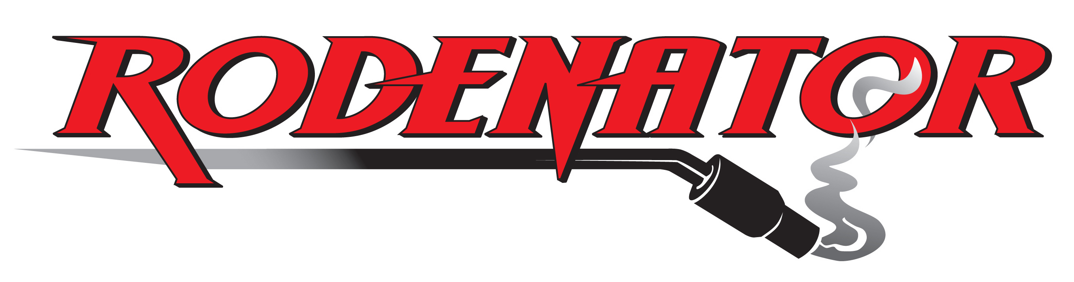

RODENATOR R2 REMOTE OPERATOR'S MANUAL

Important Notice and Statement to Users
in the United Kingdom

Before assembling and operating this equipment, it is important that this Operator's Manual is read and understood in order to use the Rodenator R2™ Remote in a safe and proper manner.

Under the laws of the United Kingdom, specifically the Wildlife and Countryside Act 1981, the Rodenator R2™ Remote CANNOT be used for the killing or taking of any wild animal.

The specific use for the Rodenator R2™ Remote device in the United Kingdom is to collapse unoccupied or abandoned animal burrow systems only.

Contact the Department for Environment, Food and Rural Affairs (Defra) with any questions you may have on the use of this device in relation to the burrow systems that you propose to collapse!

CONTENTS
Page

Important information about Defra and Natural England I
Letter from Defra II
Defra Position Statement III
Natural England Position Statement IV-V
Notice to Purchaser VI
Introduction by Edwin B Meyer VII
What you should know about the Rodenator R2 Remote Operator’s Manual VIII
Patents, Trademarks and Copyrights IX
General information and Customer Support X

Safety information and Signal Words 1
Safety Symbols 2
Equipment safety guidelines 3
Understanding the operation of the Rodenator R2 Remote device 4
Preparing to assemble the Rodenator R2 Remote device 5
Assembling the Rodenator R2 Remote device and attachments 6

Connecting gas supply hoses to regulators 7
Connecting Propane and Oxygen regulators to gas cylinders 8
Connecting gas Quick Connectors to gas supply hoses 9
Connecting gas Quick Connectors to Rodenator R2 Remote device 9
Testing connections for leaks 10-11

Adjusting regulator pressure settings on gas cylinders 12
Understanding the use of gas mixtures - Liquefied Propane Gas (LPG) 13
Liquefied Propane Gas (LPG) Warning Statement 14
Understanding the use of gas mixtures - compressed Oxygen (O₂) 15

Rodenator R2 Remote device - Safety precautions 16
Operator safety - Personal Protective Equipment (PPE) 17
Operator safety - working area 18
Operator safety - working equipment 19
Operator safety - positioning, timing and minimum safe distances 20-22

Operation - final checklist 23
Operation - preparation and firing sequence 24-25
Application guidelines - Questions and Answers 26
Maintenance and storage 27

Technical support and warranty registration 28
Rodenator R2 Remote manufacturer’s warranty, UK Lifetime Warranty 29-30
Rodenator R2 service record 31

Warranty Registration Form

Important information about Defra and Natural England

In the United Kingdom, the protection and welfare of wildlife are under the rule of the Department for Environment, Food and Rural Affairs (Defra). This government department is responsible for the conservation of wildlife and landscape.

One of Defra’s roles is to carry out visits to premises to verify that people are complying with the administrative controls contained in certain wildlife legislation. It also works with statutory enforcement authorities to effectively discharge wildlife conservation enforcement and responsibilities.

Natural England is a Defra funded agency committed to conserving and enhancing the natural environment. It is authorized to discharge certain Defra wildlife management functions, including the issuance of licences, investigation of crimes against wildlife and working in conjunction with authorities in enforcement.

Meyer Industries and Rodex Europe Limited recommend that any legal question on the application of the Rodenator R2™ Remote, for the collapse and/or removal of targeted animal burrows, is directed at Defra and/or Natural England. Their wildlife officers would be able to provide the operator with the best advice for identifying and determining if a burrow is occupied, as well as the best method to ensure that the targeted burrow is vacant.

For information about Defra and the use of Rodenator products, please refer to our website at http://www.rodenator.co.uk/Defra_2007.doc

For additional information about Defra and their position on Rodenator products:
http://www.defra.gov.uk/wildlife-countryside/vertebrates/legal-pest-control.htm

For information about Natural England:
http://www.naturalengland.org.uk/conservation/wildlife-management-licensing/default.htm

For information about European Protected Species, and
The Conservation (Natural Habitats, etc.) Regulations 1994:
http://www.opsi.gov.uk/si/si1994/Uksi_19942716_en_1.htm

Important: It is recommended, prior to commencing work with the Rodenator R2™ Remote, that you check with your local office of one of the authorities listed above, to determine if any protected species exist within the boundaries of your work area. In most cases you are likely to find that any such species will be unrelated to your proposed work and that no concerns are warranted.

However, if you do discover that a particular species may be of a concern, the appropriate agency notifying you will provide advice and options to mitigate these issues. This may be as simple as delaying work until the species has finished nesting, or has migrated to other areas for the season, for example.

I

Letter from Defra
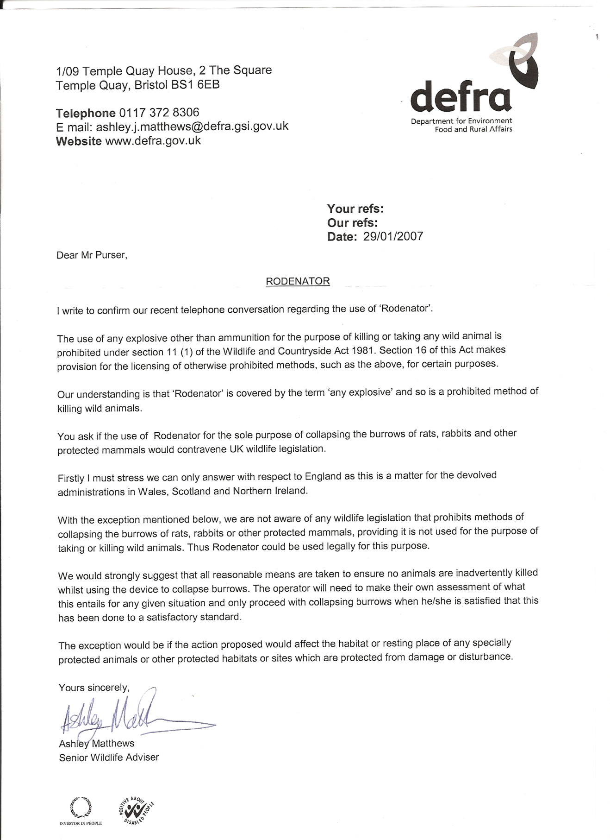

II

Defra Position Statement

DEFRA POSITION STATEMENT
May 2007

RODENATOR and SIMILAR DEVICES

This statement applies to England only as this is a matter for the devolved administrations in Wales, Scotland and Northern Ireland.

The use of any explosive other than ammunition for the purpose of killing or taking any wild animal is prohibited under section 11(1) of the Wildlife and Countryside Act 1981. Section 16 of this Act makes provision for the licensing of otherwise prohibited methods, such as the above, for certain purposes.

Defra’s understanding is that ‘Rodenator’ and similar devices are covered by the term ‘any explosive’ and so are a prohibited method of killing wild animals.

Subject to the exception mentioned below, use of methods to collapse burrows of rats, rabbits or other mammals, is not regulated in wildlife legislation. Therefore, the use of the Rodenator for this purpose would be lawful, provided that it was not used in order to kill or take wild animals.

Defra therefore strongly advises that all reasonable means are taken to ensure no animals are inadvertently killed whilst using the device to collapse burrows. The operator will need to make their own assessment of what this entails for any given situation and only proceed with collapsing burrows when he/she is satisfied that this has been done to a satisfactory standard.

The exception to using Rodenator for collapsing empty burrows would be if the action proposed would affect the habitat or resting place of any specially protected animals or other protected habitats or sites which are protected from damage or disturbance.

Wildlife Species Conservation Team, Defra

Note: As of 1 May 2007 no licenses have been granted to allow the use of Rodenator, or similar devices, for the purpose of taking or killing wild animals in England. Natural England determines such license applications on Defra’s behalf. For Natural England to consider granting such a license, scientific data would be required to allow Natural England to assess the humaneness and effectiveness of the technique.

III

Natural England Position Statement


Natural England
Wildlife Management & Licensing

Natural England calls on Rodenator
users to heed the law

Controlling rabbits, rats and other pests has never been easy but recently a novel pest control device (known as the “Rodenator”) has made its way into the UK market.

Natural England, the Government’s conservation adviser, is warning users that they could be committing an offence if they use devices such as the “Rodenator” in England as a means of killing pests

In recent years the range of control techniques available to manage some of the most problematic species affecting agriculture has narrowed, most notably with the loss of both “Cymag” (used for rabbits and rats) and strychnine (used for moles). Understandably, there has been growing interest in novel techniques to plug the gap.

The Rodenator has received widespread interest. It involves the use of a device that injects an explosive mixture of propane gas and oxygen into a tunnel system which is then electronically ignited. The claim is that the resulting shock wave will kill any animals that are present and collapse the burrows. Devices of this type were first developed in the United States in the 1990s to control a wide range of burrowing mammals and are now being imported into Europe and the UK to deal with rabbits, rats and moles.

Although designed to kill, as the Department for the Environment, Food and Rural Affairs made clear in a public statement in May 2007, Rodenator type devices must not be used for killing wild animals in this country. Legally, they can be used to collapse burrows and tunnels if there are no animals present, and used in this fashion they do not require a licence or Defra approval (no licences have been issued despite claims to the contrary e.g. Farmers Weekly 22 Feb).

Representatives of the pest control industry and animal welfare organisations have expressed concerns to Natural England following reports of apparent illegal use, and a case involving the deaths of wild rabbits was recently documented in the veterinary journal, Veterinary Record. Cases have also been drawn to the attention of the police.

The maximum penalty for using an explosive, other than ammunition for a firearm, to kill wild animals is £5,000 and six months in prison. There is a similar penalty for asphyxiating any wild animal with intent to inflict unnecessary suffering, which is a potential consequence of incomplete destruction of an occupied burrow system.

Natural England has serious concerns about the use of these devices to collapse burrows because of the practical difficulties of ensuring that burrows and tunnels are free of animals. Claims that it takes “one minute per burrow to do the job” and that the device can be used to destroy 250-300 rabbit burrows a day (Farmers Weekly 22 Feb) give rise to concern. Although a thorough and ideally repeated gassing operation using an approved pesticide could eliminate rabbits in a warren system it is unlikely that other techniques including the use of ferrets would do the job sufficiently. The findings of one study confirmed that on average, only 36% of the rabbit population was captured when one ferreting operation was undertaken.

Pest controllers, farmers or anyone else considering using such equipment to collapse empty burrows are advised to carefully consider whether or not they are confident that their proposed use of the device will be legal.
IV

Users should:

- Take all reasonable precautions to minimise the risk that the burrows are occupied by ANY wild animals, making sure that you know which species that use burrows are found in the local area. Placing twigs across entrances can help assess burrow use by larger animals, but don’t forget some species hibernate in other species’ burrows.

- If burrows are occupied, or likely to be occupied, by a problem species, the burrow system will need to be cleared of animals before it can be collapsed. This should be carried out using an effective and legal control method. The most appropriate option will depend on the animal concerned and the situation.

- If the burrow system is occupied, or likely to be occupied, by other animals and especially by protected species, then the burrow should be left undisturbed. Remember that some species, including amphibians and reptiles, may use burrows belonging to other species.

- Make sure that the burrow system is not reoccupied by any animals before the tunnels are collapsed. This will mean preventing access to the tunnels and/or minimising the time interval between clearing the burrows and destroying them.

- If you have reason to believe that there are ANY wild animals in the burrows or are likely to be in the burrows then do not collapse them.

It is also recommended good practice to keep records of measures taken to assess presence of animals and any efforts made to ensure no wild animals were in the burrows when they were collapsed.

These suggestions are offered by way of guidance, and do not in any way lessen the responsibility of users of Rodenator or similar devices to ensure they comply with the law; if in doubt users are advised to seek legal advice.

The question is often “could the Rodenator and similar devices ever be used to kill pest species in England?” The simple answer is yes, but only under an appropriate licence as they utilise a prohibited method of killing. Natural England is authorised to grant such licences on behalf of Defra in England. The Welsh Assembly Government and the Scottish Government are responsible for this issue in their respective countries. To date, there have been discussions between Natural England and importers and purchasers to advise them of the regulatory requirements but no licences permitting the use of these devices to kill wild animals have been granted anywhere in the UK and no such devices are ‘Defra approved’.

Further advice and information
Contact Paul Butt at Natural England. Tel: 01233 811265 email: paul.butt@naturalengland.org.uk

Sources
Defra position statement on Rodenator and similar devices, May 2007: www.defra.gov.uk/wildlife-countryside/vertebrates/pdf/rodenator.pdf

Bidewell C.A., Cantwell, P.J., Scholes, S.F.E. and Duff, J.P. (2008) Deaths of wild rabbits associated with a novel method of pest control. Veterinary Record 162 (5): 163

Cowan D.P. (1984) The use of ferrets (Mustela furo) in the study and management of the European wild rabbit (Oryctolagus cuniculus). Journal of Zoology, London 203, 570-574

Sullins, M. and Sullivan, D. (1992) Observations of a gas exploding device controlling burrowing rodents. Proc. 15th Vertebrate Pest Conf. (ed. J.E.Borrecco & R.E.Marsh) University of California, Davis. 308-311

February 2008
Email: wildlife@naturalengland.org.uk
Website: www.naturalengland.org.uk

V

Notice to Purchaser

E.B. Meyer, Inc. and Meyer Industries, of Midvale, Idaho, USA, give notice to the purchaser and user of the Rodenator R2TM Remote “burrow elimination system” as follows:

The purchaser and user of this product assumes all liability in the operation, application, use, and/or possession of this device, known as the Rodenator R2TM Remote “burrow elimination system”, and releases the manufacturer, E.B. Meyer, Inc. and Meyer Industries, and their agents, distributors, and/or dealers, of any liability and/or damages, in whole or part, including but not limited to the Rodenator device, purchased accessories, gauges, hoses and safety equipment.

The purchaser and user agree to comply with all terms and conditions to the limited warranty, including acceptance that the Rodenator R2TM Remote device is for single user only.

The Rodenator R2TM Remote device cannot be used for rental, co-operative or lease applications. Renting or leasing of this device will void your warranty.

If you are not in agreement with the above terms and conditions of this release of liability, do not use this product.

Instead, immediately notify the seller, Rodex Europe Limited, that you do not accept the terms of this agreement.

Any indication of usage, including the assembly, and/or application of this product, is considered acceptance of the agreement, whereby the purchaser and user stipulate(s) that liability has been accepted and the purchaser and user have released their rights for claims and damages against E.B. Meyer, Inc. and Meyer Industries, and their agents, distributors, and/or dealers of any liability and damages, in whole or part, including but not limited to the Rodenator device, purchased accessories, gauges, hoses, and safety equipment.

Time Limitation: Upon accepting delivery of this product, which includes this Operator’s Manual, the purchaser and user is required to notify Rodex Europe Limited of their intent not to agree to the terms of this release of liability.

This notification must be postmarked by certified mail within 5 calendar days after delivery.

Expiration of the time limitation without notice indicates that you have accepted the terms and conditions set forth by this release stated above.

VI

Introduction by Edwin B Meyer

Thank you for purchasing the Rodenator R2™ Remote “burrow elimination system”. You have the finest device on the market for obtaining complete control of burrowing pests while protecting the environment from toxic chemicals and pesticides.

Manufactured by Meyer Industries, the Rodenator R2™ Remote is designed for farmers and land managers, and is intended for rigorous use by agricultural, commercial and residential users worldwide.

The Rodenator R2™ Remote is made and assembled at our factory in the town of Midvale, Idaho, USA. This rural community is rich in history and represents a small “western town” in the Snake River region of Southwestern Idaho.

The employees of Meyer Industries take pride in the manufacturing of the Rodenator R2™ Remote. Their dedication to the development, research, quality control and customer support is a reflection of this town’s values and way of life.

Meyer Industries is always at the forefront of technology. We continually seek advice and recommendations from universities across the USA and frequently commission public studies to demonstrate the effectiveness of the Rodenator products with varied species and applications. We also seek recommendations from our customers who apply our products in varied environments.

In January of 2006, the RodenatorTM products received US and International approval and verification for use in organic farming applications through Custom Certification Services (CCS). Our products are now recommended for use by the Organic Crop Improvement Association, International (OCIA), one of the world's oldest, largest and most trusted leaders in the organic certification industry, and many other organic certification and accreditation organizations across the United States, Europe and Japan.

With the exception of traps, our RodenatorTM products are the only devices on the market today that can be used in organic applications.

With our excellent product support and warranty programs, the Rodenator R2™ Remote “burrow elimination system” is a tool that will always give unparalleled results.

When you purchase the Rodenator R2™ Remote or any other product from Meyer Industries, you are becoming not just a customer, but a part of our community.

Edwin B. Meyer, President
E.B. Meyer, Inc.

VII

What you should know about
the Rodenator R2 Remote Operator’s Manual

This Operator’s Manual is intended to provide the purchaser and user with comprehensive information relating to the safety, operation and recommended application techniques for the Rodenator R2™ Remote “burrow elimination system” only.

You are advised to completely read this Operator’s Manual before assembling and operating this device. Failure to read and understand this Operator’s Manual may result in safety issues and performance problems.

This Operator’s Manual and the suggested Rodenator R2™ Remote “burrow elimination system” application techniques are specific to this product and are not applicable to similar products or devices.

All warnings and notices in this Operator’s Manual are intended to give you necessary information for the safe and efficient operation of the Rodenator R2™ Remote “burrow elimination system”.

Please study this Operator’s Manual carefully.

Both your safety and the safety of others depend on it!

If you have any questions regarding the assembly, operation or application techniques of the Rodenator R2TM Remote device, cease operation.

Immediately contact Rodex Europe Limited Customer Support:

Tel. 07739 799721 or 01480 890348, or

Email your questions to technical@rodenator.co.uk

VIII

Patents, Trademarks and Copyrights

The Rodenator R2™ Remote “Burrow Elimination System”, and all affiliated names, brand and trade names, trademarks, this Operator’s Manual and related materials, documents and videos, are protected by federal, state and international patent, trademark and copyright laws.

All materials, including, but not limited to, written documents, brochures, web and/or internet information, videos, newsprint and magazine articles, trade names, tag lines and logos are protected and cannot be duplicated, in any way, shape or form, without the prior express written authorization of E.B. Meyer, Inc.

Any attempt to copy, reproduce and/or publish this Operator’s Manual is strictly prohibited.

Meyer Industries will pursue any party or persons infringing our patents, trademarks and copyrights, to the fullest extent of the law.

IX

General information

Defra Information:

Rodenator R2™ Remote Burrow Elimination System is restricted for use in England for collapsing the burrow systems of abandoned or unoccupied animal tunnels, burrows or dens. This device is not to be used for the killing of wildlife without specific licensing or authority by public law.

EPA Information:

The Rodenator R2™ Remote Burrow Elimination System is registered with the United States Environmental Protection Agency (EPA) as an Application Device. The EPA Establishment number is Number 079470-ID-001.

Patents, Trademarks, and Copyright:

The Rodenator R2™ Remote Burrow Elimination System is registered with the U.S. Patent and Trademark Office with additional U.S. and Foreign Patents Pending.

Meyer Industries prohibits the use of our patents, trademarks and copyrights and is protected by law.

Organic Verification:

The Rodenator R2™ Remote Burrow Elimination System is verified for use in organic applications through Custom Certification Services (CCS) of Nebraska. The following countries have verified its use:

- The International Federation of Organic Agriculture Movements (IFOAM)
- The Costa Rica Ministry of Agriculture and Livestock (MAG)
- Japan Agriculture Standards (JAS)

A copy of this verification is included at the end of this Operator’s Manual.

Customer support

If you have any questions regarding the assembly, operation or application, have questions not answered in this manual, or if your manual is damaged or misplaced, or you require additional copies for whatever reason, cease operation.

Immediately contact Rodex Europe Limited Customer Support:

Tel: 07739 799721 or 01480 890348, or

Email your questions to technical@rodenator.co.uk

X

Safety information

Safety alert symbols found throughout this manual are used to bring your attention to instructions involving both your personal safety and the safety of others

FAILURE TO FOLLOW THESE INSTRUCTIONS MAY RESULT IN SERIOUS INJURY!


SIGNAL WORDS

Use of the following signal words DANGER, WARNING, and CAUTION with safety messages. Appropriate signal word for each has been selected using following guidelines:

Indicates an imminently hazardous situation that, if not avoided, will result in death or serious injury.
DANGER

Indicates a potentially hazardous situation that, if not avoided, could result in death or serious injury. It may also be used to alert against
WARNING
unsafe practices.

Indicates a potentially hazardous situation that, if not avoided, may
CAUTION
result in minor or moderate injury. It may also be used to alert against
unsafe practices.

IMPORTANT NOTICE

If you have any questions regarding the safety words or signals, do not operate this
equipment until you have a full and clear understanding of the danger statements, warnings and cautions in this Operator’s Manual.

If you have any questions regarding the assembly, operation, or application techniques of the Rodenator device, cease operation.

Immediately contact Rodex Europe Ltd Customer Support on Tel: 07739 799721 or 01480 890348, or email your questions to technical@rodenator.co.uk

1

Safety Symbols

The following important Safety Symbols are associated with the operation of the Rodenator R2TM Remote:

 Indicates that the container or vessel contains a flammable gas that can ignite in the presence of flame, spark, heat or friction.

 Indicates that the container or vessel contains a non-flammable gas that can react to the presence of flame, spark, heat, friction or oil.

 Indicates that protection of head, eyes and hearing is required.
Please use the personal protection equipment (PPE) provided.

Please take note of these safety symbols which are associated with this Operator’s Manual and the Rodenator R2TM Remote device.

2

Equipment safety guidelines

Every year, many farm, ranch and industrial accidents occur that could have been avoided by observing safety precautions and following recommended operating procedures prior to operating or handling equipment.

You, the operator, can avoid accidents by observing all precautions in this Operator’s Manual:

- Do not allow persons to operate or assemble the Rodenator R2 TM Remote device or accessories until they have read the operator’s manual and have developed a thorough understanding of the safety precautions and the proper operation of this equipment.

- To avoid personal injury, study the precautions in this Operator’s Manual and insist that those working with you also follow those precautions.

- Do not attempt to operate the Rodenator R2TM Remote device under the influence of alcohol or drugs.

- Do not cover up, paint over, remove, or deface any safety signs or warning decals on your Rodenator R2 TM Remote device. If any safety, warning or instructional decals are damaged or missing, contact Rodex Europe Ltd Customer Support:

Tel: 07739 799721, 01480 890348 or +441480 890348 for immediate replacement.

- Never exceed the limits of this device. If its ability to do a job, or to do so safely is in question, cease operation immediately and contact Rodex Europe Ltd Customer Support on Tel: 07739 799721 or 01480 890348.

- Your best assurance against accidents is being a careful and responsible operator. Please familiarize yourself with the safety warnings in this Operator’s Manual. If you do not fully understand how to apply the safety protocols in the application of this device, cease operation immediately and contact Rodex Europe Ltd Customer Support on Tel: 07739 799721 or 01480 890348.

DO NOT ATTEMPT TO MODIFY OR REPAIR THE RODENATOR R2 TM REMOTE DEVICE IN ANY WAY, SHAPE OR FORM. DO NOT ATTEMPT TO MODIFY REGULATORS, HOSES, FLASH ARRESTORS OR CHECK VALVES.

ALL EQUIPMENT PROVIDED BY THE MANUFACTURER HAS BEEN SPECIFICALLY DESIGNED FOR OPTIMAL PERFORMANCE AND SAFETY. USE EXACTLY WHAT HAS BEEN PROVIDED.

ANY MODIFICATIONS, UNAUTHORIZED REPAIRS, AND/OR FAILURE TO USE COMPONENTS SUPPLIED WITH THE RODENATOR DEVICE WILL VOID YOUR WARRANTY!

3

Understanding the operation
of the Rodenator R2™ Remote device

The Rodenator R2™ Remote “Burrow Elimination System” is an EPA registered application device that injects a calibrated mixture of liquefied propane gas (LPG) and compressed oxygen (O₂) into the tunnels of burrowing animals.

This application is timed from 2 seconds to 3 minutes, depending on the type of unoccupied burrow system that is being treated.

The calibrated mixture dispensed is <2% liquefied propane gas (LPG) and around 98% compressed oxygen (O₂).

During the application, it is recommended that the operator uses a stopwatch or timer for each and every application to ensure that the amount of gas being injected is properly within the recommended application protocols and to ensure safety of the operator and bystanders.

When the recommended time for injection of gases is complete, the operator ignites the mixture by actuating the electronic ignition module button, located on the control box. This initiates a low amperage, high voltage arc caused by a spark plug within the nozzle, causing the gas mixture to detonate within the tunnel system.

The detonation of the propane causes the oxygen to violently react, creating a massive concussive force that travels through the tunnel system which generally disrupts a large portion of most closed tunnel systems, causing them to collapse. This process has been documented repeatedly by extensive field trials and customer response.

Propane and oxygen are the only gas mixtures approved for use
DANGER
with the Rodenator R2TM Remote device.

Any attempt to use acetylene, vaporized gas or Mapp gas, is
dangerous and ineffective with this device.

Due to the explosive nature of propane and oxygen, it is
extremely dangerous to attempt to duplicate this propane and
oxygen process or to experiment with equipment that is not
designed or intended for use with subterranean destruction of
unoccupied or abandoned animal burrows.

Home-made devices have been known to cause serious injuries
and burns.

4

Preparing to assemble
the Rodenator R2™ Remote device

In order to properly assemble the Rodenator R2™ Remote “Burrow Elimination System”, check all items against the following inventory to ensure that all components are in proper order and have not been damaged in transit. Check off each of the components listed:

Component List

Box 1

- Rodenator R2™ Remote device

- Wireless Remote Control

- Plug-in antenna and velcro tie

- Battery Charger

- Flash Arrestors / Adaptors

- Flexible Injection Nozzle (ideal for rabbit burrows)

- Fixed Injection Nozzle (ideal for rat and mole tunnels)

- Operator’s Manual

- Warranty Registration Form

Box 2 (“Accessory box”)

- Propane regulator

- Oxygen Regulator

- 15 m of Dual Hose

- Safety Helmet

- Safety Goggles

- DVD

5

Assembling the
Rodenator R2™ Remote device and attachments

The Rodenator R2™ Remote “Burrow Elimination System” device contains the complete internal electronic controls, ignition mechanism, gas proportioning valves and flashback arrestors within the rectangular base unit (or black box) which is assembled at the factory.

All of the electronic controls, safety switches and batteries are also contained within this sealed base unit, which is attached to the applicator shaft.

Warning: Do not attempt to open the Rodenator R2TM Remote base unit or disassemble the internal components of the device without factory
or agent prior authorization.

Any unauthorized disassembly or repairs will void the warranty!

Antenna

Plug the antenna coupling into its connection on the end of the base unit, lining it up correctly on the guide spline and push home snugly, then turn the locking collar forward and then rotate it clockwise until it is fully locked. Use the Velcro strap to secure the antenna to the gas pipes, once connected, for additional support.

Battery and battery charging system

The Rodenator R2™ Remote comes with internal rechargeable lithium-ion batteries and its own battery charging system.

This charging system is the only one that will work for the Rodenator R2™ Remote device.

Important: New batteries are shipped discharged for safety reasons and must
therefore be fully charged prior to first use.

- Plug the A/C charging unit into a standard household electrical outlet. Insert the charging plug into the Rodenator R2TM Remote device marked “Charge”.

- Charging may take up to 10 hours for the first or initial charge. A solid green light indicates that the batteries are charging.

- When the charging indicator goes from green to flashing green, the batteries are fully charged.

Warning: The rechargeable battery in this device is not user serviceable.

Do not attempt to use any other charging device to recharge the batteries of the Rodenator R2TM Remote device.

6

Connecting gas supply hoses to gas regulators

CAUTION

- The connections are compression fittings and do not require the use of pipe or thread sealant or thread tape for connections.

- The green hose attaches to the oxygen regulator (green for oxygen). Hand-tighten in a clockwise motion, followed by a nip with a wrench for a snug fit.

- The red hose attaches to the propane regulator (red for propane/fuel) using a counter-clockwise motion. Hand-tighten, followed by a nip with wrench for a snug fit.

- Use UK specification hoses and regulators that are approved for the use of propane gases only.

WARNING

Do not over-tighten the gas hose connections. The thread direction on the hoses
prevents accidental cross connection hook-ups (oxygen vs. propane).

The coupling nut on the propane fuel connection is identified with grooves stamped into the coupler. This is a reverse, or left-handed, thread (turn anti-clockwise to tighten).

The coupling nut on the oxygen connection has no identifying marks on the coupler and is a standard thread (turn clockwise to tighten).

Refer to the Manufacturer’s instructions supplied with each regulator for additional information on connection and tightening procedures.

7

Connecting Propane and Oxygen regulators to gas cylinders

CAUTION

Liquefied Propane Gas (LPG) is extremely cold in its liquid state. It is recommended that eye protection and gloves are worn when connecting the regulators.

Before connecting regulators, please read the instructions and warnings supplied and included with the oxygen and propane regulators and familiarize yourself with the operating instructions for these regulators.

- Attach the dual fuel (propane) regulator to the propane tank. Use an anti-clockwise motion to hand-tighten the fitting of the propane regulator to the propane tank. Complete the attachment using a spanner or an adjustable wrench to secure the connection. Do not over tighten.

- Attach the oxygen regulator to the oxygen tank (O2), using a clockwise motion to hand-tighten the female fitting of the oxygen regulator to the oxygen tank. Complete the attachment using a spanner or adjustable wrench to secure the connection. Do not over tighten.

- The propane bottle must stand upright at all times.

8

Connecting gas Quick Connectors
to gas supply hoses

There are two male connecting points from the gas quick connectors to the gas supply hoses.

- The gas quick connectors are designed to attach to the Rodenator R2™ Remote by a simple plug-in motion. These quick connectors are designed to connect the gas supply hoses that are connected to the two gas regulators.

- The green hose attaches to the green quick connector (green for oxygen). Hand-tighten in a clockwise motion, followed by a wrench for a snug fit. Do not over-tighten.

- The red hose attaches to the red quick connector (red for propane/fuel) using an anti-clockwise motion. Hand-tighten, followed by a wrench for a snug fit. Do not over-tighten.

Connecting gas Quick Connectors
to Rodenator R2TM Remote

- Pull back on the quick connector collar and plug into the corresponding colour:

Red for fuel (propane), green for oxygen

WARNING

Do not over-tighten any of the gas connections.

These parts are made of brass and may deform if too much pressure has been applied.

Over tightening may cause a dangerous gas leak or performance issues.

9

Testing connections for leaks

It is necessary to perform a leak test on all connections by using an oxygen safe
commercial leak test solution. Failure to test for leaks may lead to dangerous gas leakage
or performance issues.

Oxygen Leak Test:

1 Check all connections to ensure that they are tight and secure.

2 Turn off the propane and oxygen adjustment controls. Turn off the Rodenator R2!

3 Prior to opening the oxygen tank valve, loosen the oxygen pressure regulator adjustment screw (left or anti-clockwise turn) 1 to 2 turns. This will eliminate overpressure to the regulator gauges when the tank valve is opened.

4 Carefully open the tank valve on the oxygen tank only. Adjust line pressure to 30 psi, although under some working conditions this may need to be increased to 35 psi.

5 Use leak testing solution on all connections, beginning at regulator connection to tank and continuing to all hose connections, quick connectors and flash arrestors.

6 If a leak is detected, close the oxygen tank valve, wait for pressure to bleed off, tighten leaking connection and re-test.

When connections are tight and no leaks are detected, close the oxygen tank valve, and proceed with Propane Leak Test.

Propane Leak Test:

1 Check all connections to confirm that they are tight and secure.

2 Close propane and oxygen adjustment controls. Turn off the Rodenator R2!

3 Carefully open the tank valve on the propane tank only. Adjust line pressure to 15 psi, although under some working conditions this may need to be increased to 20 psi.

4 Use leak testing solution on all connections, beginning at regulator connection to tank and continuing to all hose connections, quick connectors and flash arrestors.

5 If a leak is detected, close the propane tank valve, wait for pressure to bleed off, tighten connection and re-test.

When connections are tight and no leaks are detected, close the propane tank valve, and continue with the assembly procedure in this Operator’s Manual.

10

Testing Connections for Leaks - Continued

DANGER

Do not use any petroleum products on or near the equipment, regulators and hoses, including oils, solvents and cleaners.

Do not use any cleaners or solvents that are not “oxygen safe”.

Make sure that hands and tools are free of oil and grease.

Oxygen vigorously accelerates combustion and may form explosive compounds when exposed to combustible materials or oil, grease and other hydrocarbon materials.

Improperly cleaned equipment and piping could result in a combustion reaction causing damage to equipment and injury to personnel.

When performing leak tests, the use of an “oxygen safe” testing solution is essential to preventing contamination of your oxygen source.

If you are unsure of the product you are using for leak testing, consult a welding or oxygen supply dealer for recommended products that are “oxygen safe” and free of oils and hydrocarbons.

11

Adjusting regulator pressure settings on gas cylinders

DANGER

Do not carry out the following procedures in a confined or enclosed space.

The oxygen pressure must be set first, and the oxygen kept in flow through the R2 whilst the propane pressure is then set.

Compressed Oxygen (O₂) :

1 Prior to opening the oxygen tank valve, loosen the oxygen pressure regulator
adjustment screw. This will eliminate over-pressure to the regulator gauges when the tank valve is opened.

2 Slowly open up the oxygen cylinder outlet to the fully open position.

3 Adjust the oxygen regulator to 50 psi reading on the gauge by turning the pressure
adjustment knob on the regulator.

4 After your initial adjustment to the regulator settings, occasionally check the pressure
settings while the gas is flowing to ensure that the pressure remains correct.

Liquefied Propane Gas (LPG) :

1 Oxygen must be in flow while setting propane pressure.

2 Slowly open up the propane cylinder outlet to the fully open position.

3 Adjust the propane regulator to 30-36 psi reading on the gauge by turning the
pressure adjustment knob on the regulator.

4 After your initial adjustment to the regulator settings, occasionally check the pressure
settings while the gas is flowing to ensure that the pressure remains correct.

It is recommended that the pressures of both regulators are periodically checked
while gas is flowing through the hoses.

12

Understanding the use of gas mixtures

Understanding the combined effects of both propane and oxygen in the use of the Rodenator R2™ Remote is very important.

The Rodenator R2™ Remote uses a proprietary method to proportion, compress and inject the gas mixture into the tunnels of burrowing animals. The proportions of gases in the mixture are less than 2% liquefied propane gas (LPG) and around 98% compressed oxygen (O₂).

This mixture produces a compressed and consistent ratio of propane and oxygen at a consistent measured pressure into the tunnel system. Upon combustion, the resulting concussive shockwave travels throughout the tunnel system at over 10,000 psi.

This massive concussive force is sufficient to collapse the targeted burrow system.

The combustion of liquefied propane gas (LPG) and oxygen (O2) produces carbon dioxide (CO₂) and water vapor which are non-toxic to the environment.

Liquefied Propane Gas (LPG)

- Propane is a highly flammable gas. It is heavier than air, which gives the mixture added weight for better tunnel penetration and to assist the oxygen in the process of rapid expansion.

- Always maintain proper regulator and valve settings, as excessive propane creates a potential fire hazard and slows down the shock wave, normally resulting in a fire.

DANGER

FIRE HAZARD
Liquefied Propane Gas (LPG) is a highly flammable gas vapour that produces an explosive mixture with air and will easily ignite by heat, sparks, flames, build-up of static electricity and other sources of ignition. Do not smoke or use electrically operated devices while connecting and/or operating this device.
Propane gas is denser than air and may flow along the ground, sinking to the lowest level of the surroundings and can be ignited at a considerable distance from the source of leakage.

13

Liquefied Propane Gas (LPG) Warning Statement - Continued
Propane contains an odorizer to alert users of leakage. Test all connections with an oxygen safe leak detection liquid to assure tight fittings and connections. If you detect a leak, immediately close all tank valves. Do not check for leaks with an open flame!
If a leak is detected from the propane tank and you are unable to secure the leak, immediately evacuate the area and contact the Fire Brigade.
Refer to the relevant Safety Data Sheets for these materials before using, to familiarize yourself with the precautions for handling, storage, firefighting and proper use of these materials.

WARNING

INHALATION HAZARD

At very high concentrations in an enclosed area, liquefied propane gas (LPG) vapor is an asphyxiant which will decrease the availability of oxygen. This product will displace oxygen if released in a confined space. Maintain oxygen levels above 19.5% at sea level to prevent asphyxiation. Inhalation of high concentrations may cause dizziness, disorientation, loss of coordination or loss of balance, narcosis, nausea or narcotic effects.

CAUTION

EXTREME COLD HAZARD - EYE AND HAND PROTECTION

Liquefied Propane Gas (LPG) in its liquid state can cause cryogenic burns to the skin similar to frostbite.

Protective clothing, including hand and eye protection is recommended when affixing connections and testing for leaks.

Refer to the relevant Safety Data Sheet for these materials before using, to familiarize yourself with the precautions for handling, storage, firefighting and proper use of these materials.

14

Understanding the use of gas mixtures: compressed Oxygen (O₂)

Compressed Oxygen (O₂)

- Oxygen is an oxidizer that rapidly accelerates with an ignition source (propane).
This rapid expansion creates a concussive force of 10,000 psi which travels throughout the tunnel system as a shockwave at over 5,000 m/second.

- Always maintain proper regulator and valve settings, as excessive compressed oxygen will cause improper detonation of the propane, which may create a potential fire hazard.

DANGER

FIRE HAZARD
Compressed Oxygen is a non-flammable gas that vigorously accelerates the combustion process of the propane within the tunnel or burrow.
Do not smoke or use electrically operated devices while connecting and/or operating this device.
Test all connections with an oxygen safe leak detection liquid to assure tight fittings and connections. If you detect a leak, immediately close all tank valves. Do not check for leaks with an open flame!
If a leak is detected from the oxygen tank and you are unable to secure the leak, immediately evacuate the area and contact the Fire Brigade.
Do not use oil on any fittings. Keep safety caps on oxygen cylinders at all times.
Refer to the Material Safety Data Sheet on these materials before using to familiarize yourself with the precautions for handling, storage, firefighting and proper use of these materials.

15

Safety precautions
Rodenator R2TM Remote

Learn how to handle your Rodenator R2TM Remote safely. Failure to read, understand and follow these recommendations can result in serious personal injury and/or property damage.

WARNING

The Rodenator R2™ Remote Burrow Elimination System is designed and intended for use as a device for collapse unoccupied or abandoned burrowing animal systems only.

Using this device outside of the scope of what it is intended for, and not in accordance with this Operator’s Manual and public law, is strictly prohibited.

Any intentional misuse of this device may compromise the safety of the user or bystanders and may void the warranty.

Any intentional misuse of the Rodenator device outside of the scope of collapsing unoccupied or abandoned burrowing animal tunnel systems can be deemed to be a violation of public law in the United Kingdom.

The user of this device understands and agrees that no warranties or guarantees have been made on the performance of the Rodenator R2™ Remote Burrow Elimination System.

Total responsibility for the safe operation of this device lies solely upon the user and not with the manufacturer, Meyer Industries and/or their representatives.

REMEMBER, the best assurance against accidents is being a careful and responsible operator. Please familiarize yourself with the safety warnings in this Operator’s Manual.

If you have any questions regarding the assembly, operation or application techniques of the Rodenator device, cease operation. Immediately contact Rodex Europe Limited Customer Support on Tel: 07739 799721 or 01480 890348.

Alternatively, email your questions to technical@rodenator.co.uk

16

Operator safety

Personal Protective Equipment (PPE)

It is recommended and advised that Rodenator R2TM Remote operators wear the following items:

Clothing

- Wear long sleeved shirt and trousers.

- Wear gloves to protect hands.

- Never wear shorts, t-shirts or any highly flammable clothing.

Shoes

- Wear footwear that completely encases the foot and ankle.

- Wearing work boots is recommended. Trainers are not acceptable.

- Never work without recommended footwear.

Head, face and hearing protection

- Wear safety glasses and hearing protection.

- Provide additional hearing and eye protection to workers or observers standing nearby.

17

Operator safety - working area

CAUTION

KEEP THE APPLICATION SITE CLEAR OF BYSTANDERS

- Flying dirt or mud may cause injuries.
- Loud noise may cause hearing loss or frighten people, pets or livestock.
- Keep bystanders (especially children) and pets a minimum of 30 metres from the work area.
- Provide eye and hearing protection as required.

Flammable Materials

- Do not use in or near dry grass and brush.
- Exercise caution when working near fuel containment areas, propane tanks, underground fuel tanks and buildings.
- Carry an approved fire extinguisher for suppression of grass or brush fires.

DANGER

FIRE HAZARD

- Do not make any applications within 60 metres of any surface or underground flammable storage containers or tanks.
- Maintain a distance of 60 metres from any other flammable storage areas.
- Do not use within 30 metres of a septic tank or drain system.
- Propane and oxygen are the only gases to be used in the R2™ device.
- NEVER use acetylene, Mapp gas or vaporized gasoline.

Noise

- The discharge noise from the R2™ device may be loud.
- Wear hearing protection at all times.
- Ensure that bystanders within 30 metres of the application area wear hearing protection.
- Notify neighbors before operating the R2™ device.
- Consider contacting local law enforcement prior to use to avoid false calls.

18

Operator safety - working equipment

Check your equipment frequently

- Test hose connections and all threaded connections/connectors with an “oxygen safe” leak tester to assure that all connections are tight.
- Check gauges and hoses regularly to assure proper settings and tank volumes.

Treat the equipment with care

- Treat the Rodenator R2TM Remote device as you would handle and secure a firearm.
- Do not throw the Rodenator R2TM Remote device unit into the bed of a truck or vehicle.
- Keep the unit racked and secured while travelling.
- Close both tank valves and bleed system prior to transporting to and from work area.
- Store equipment is a secure area and away from children.

Secure all gas cylinders to vehicle bed

- Take every precaution to prevent cylinders from bouncing, over-turning, and damaging the gauges.
- Use government approved valve protection caps while regulators are not connected to valves.
- Use government approved safety caps when regulators are connected to valve.
- Use government approved devices to secure cylinders to vehicle, trailer or ATV.
- When in use, store cylinders in upright position, secured to tank cart or chained to wall.
- Check with your propane and oxygen supplier on local and state laws regarding the transporting and securing of the gas cylinders.

Notice: For additional information on the transportation of pressurized gas cylinders by vehicle on public roads, consult the following:

- Local propane and oxygen supplier

- UK Department of Transport

- The Health and Safety Executive (HSE)

19

Operator safety - Rodenator R2 positioning
1/
Take great care not to place the Rodenator within the blast zone! Exposing the machine to the full concussive force by inserting it into the burrow can result in trauma damage to sensitive internal components. Instead, use the flexible nozzle extension pipe provided to keep the machine well clear of the blast zone, as shown below:
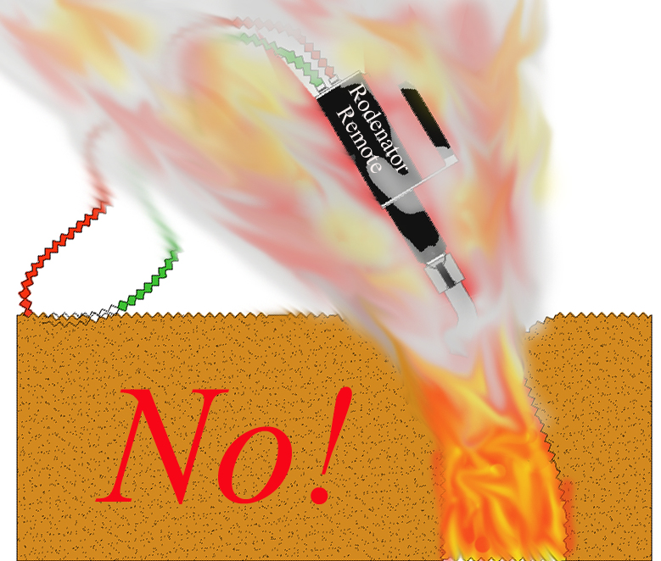
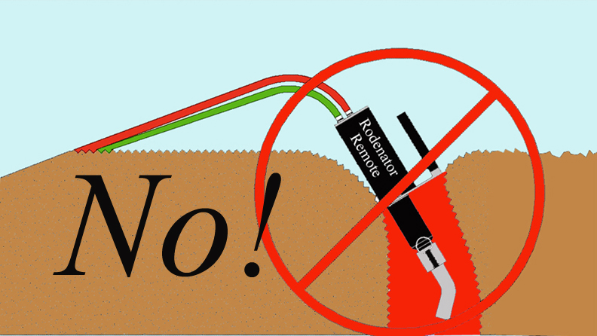
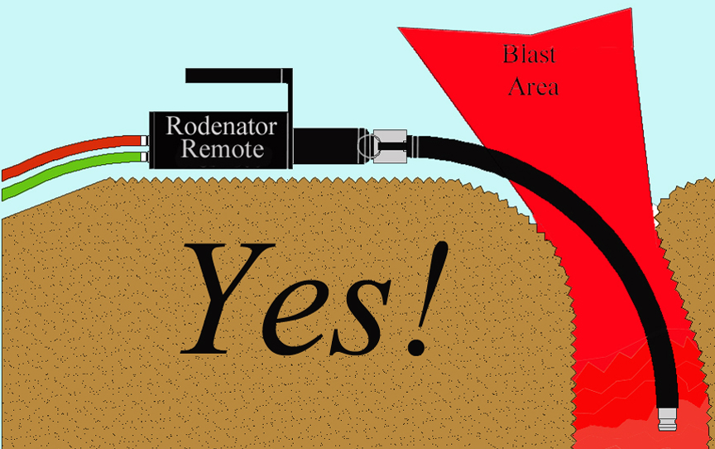

20

Operator safety - operator positioning

- Stand clear of the application area and do not stand directly in front of the hole.
WARNING

Stand on firm soil only

- Due to the shockwave generated at the time of ignition, the operator must exercise caution to limit exposure of himself to the concussive forces exiting open holes.
- Position yourself at least 6 metres from the application area to avoid shockwave.
- Face away from blast.
- Look around for other materials that may become airborne and could cause injury.

Operator safety - timing of gas applications

Timing the application

- To prevent over-gassing a tunnel or burrow system, it is recommended that the operator times the gas application with a watch that can count seconds.
- Timing of the application will vary with the type of animal burrow, soil composition and soil moisture.

Recommended gas application times

We advise gassing times of:

20 seconds to 1 minute for mole tunnels

30 seconds to 1.5 minutes for rat holes

30 seconds to 3 minutes for rabbit burrows; 3 minutes advisable for larger burrow systems

Note: Over-application of gas into a tunnel or burrow system wastes propane and oxygen.

If in any doubt on appropriate gassing times, please call Rodex Europe Limited Customer Support on 07739 799721 or 01480 890348

Do not restrict the tunnel system opening

- Objects placed over open holes may create the potential hazard of flying debris.
- If using a towel or rag over open hole burrows on windy days, dampen the material to prevent it from possibly smouldering.
- Use of soil is acceptable, but beware of the projectile risk of stones and flints etc.
- Do not place the Rodenator R2TM Remote within the blast zone! (see p.20)

21

Minimum safe distances

DANGER

Keep a minimum distance of 60 metres away from any above ground propane or fuel storage tanks, or further if it is known or suspected that connecting burrows run towards them.

Keep a minimum distance of 60 metres from any underground propane or fuel storage tanks, or further if it is known or suspected that connecting burrows run towards them.

WARNING

Exercise extreme caution when operating the Rodenator R2TM Remote near people, vehicles, buildings and domestic animals. Beware the risk of damage or injury from flying debris, particularly to glass windows of parked work vehicles.

Bystanders should remain a minimum of 25 metres away from the application work area due to the risks of both noise and flying debris.

The minimum safe operating distance from any building should be 15 metres, or further if it is known or suspected that connecting burrows run towards them.

If working near buildings or structures determine the location of septic systems, and exercise a minimum safe operating distance of 25 metres from the holding tank and connecting pipelines.

22

Operation: final checklist

Ensure proper operation, maximum safety and good results

- Wear protective clothing and safety gear.

- Inspect the Rodenator R2TM Remote device unit daily on work days.

- Check all hoses and connections for leaks. Use “oxygen safe” leak tester.

- Check fire prevention equipment. Have fire extinguisher or shovel at hand.

- Set gauges and valves. Monitor gas usage to avoid running out of gas unexpectedly.

- Clear the area of bystanders.

- Proceed with the application.

- Ensure Rodenator R2TM Remote is placed well clear of the blast zone (see p.20).

- Announce the firing of the device.

- Make doubly sure that you are performing the application to unoccupied or abandoned animal burrows.

- Contact your local Defra or Natural England wildlife official if you have any questions relating to the application of this device.

If you have any questions regarding the assembly, operation or correct application of the Rodenator R2TM Remote device, cease operation.

Immediately contact Rodex Europe Limited Customer Support:

Tel: 07739 799721 or 01480 890348, or

Email your questions to technical@rodenator.co.uk

23

Operation: preparation and firing sequence

Preparation

Inspect equipment before each day's use

Look for equipment damage to:

- Regulators and gauges;
- Valves and knobs;
- Hoses and hose fittings;
- Gas cylinders and valves; and
- Applicator shaft and nozzle, ignition button, applicator head, and black box damage.

Keep equipment clean

- Clean away dirt from the unit using a damp cloth, wipe down with a dry cloth.

Test the ignition regularly

- The ignition signal, identifiable as a rapid click, should be strong and audible.
Re-charge the rechargeable batteries when necessary.

Inspect applicator head frequently

- Check for dirt or mud inside the nozzle head. Remove any dirt or mud build-up with a dry cloth.

WARNING

HIGH VOLTAGE

Never place fingers inside the applicator head (nozzle) while the ignition button is being pressed.

Turn off the device if the application nozzle requires cleaning or if debris needs to be removed.

24

Firing the device

- Turn on the Rodenator R2TM Remote unit

On the back of the Rodenator R2TM Remote “black box” base unit, press and hold the black “ON/OFF” button until the power indicator flashes red. Release the button.
A flashing red light indicates that the device is powered and ready. Please note that if left inactive for 5 minutes the machine will turn itself off and will need to be turned back on again. This is a safety and energy saving mechanism.

- Place the nozzle of the device into the burrow entrance

Check the area for potential debris and clear the area of bystanders. Retreat.

- Using the remote control key pad

  - Press green button, No. 3 (“FLOW”) to start the flow of gas fuel.

This gives a 3 minute pre-programmed gas flow, which can be stopped early by pressing green button No. 3 again to stop the flow at any time. Pressing the button a 3rd time will start the pre-programmed 3 minute flow sequence again.

When the device is injecting gas, the gas flow indicator on the base unit will operate, showing a steady green light.

  - Press the yellow button, No. 2 (“ARM”) to prepare the R2 unit for firing.

  - Announce the firing of the device to any bystanders or colleagues by calling out
“PREPARE TO FIRE” followed by “FIRING” three (3) seconds before discharge.

  - Finally, press and hold down the red button, No. 1 (“FIRE”) to ignite the dispensed fuel. (Keeping firm pressure on this button is important for ignition).

Important:

- delaying 5 seconds between the end of gas FLOW (green light on base unit going off) and pressing the yellow (ARM) and red (FIRE) buttons, stops these buttons from functioning, as a safety mechanism. To resolve, press the green button twice (on and off straightaway) to allow the yellow and red buttons to become ‘live’ again.

- the key pad includes a blue button, No. 4, to reduce pre-programmed flow of gas to 30 seconds for each time it is pressed up to 4 times at once (i.e. resulting in 2 minutes of gas flow). If required, it should be pressed after pressing the green No. 3 button, to give optional measured doses of gas below the standard 3 minutes resulting from pressing the green button once. However, because the green button can be pressed a 2nd time to end gas flow at any time before 3 minutes has elapsed, operators using a timer can ignore the blue button No. 4.

25

Application guidelines

Introduction

The Rodenator R2™ Remote Burrow Elimination System is designed for the elimination of unoccupied or abandoned subterranean animal burrows, dens and tunnels.

As previously clearly stated in this Operator’s Manual, safety is paramount when operating the Rodenator R2TM Remote. Please familiarize yourself with the safety warnings herein.

If you are not clear or do not fully understand how to apply the safety protocols in the application of this device, cease operation and call Rodex Europe Limited Customer Support for advice.

Questions and Answers

The following questions are often asked and may provide insight into certain situations that fellow Rodenator R2™ Remote Burrow Elimination System owners have experienced.

Q. What about damage to nearby underground irrigation and water pipelines?

A. There have been no reported cases of damage to buried concrete pipes, or PVC piping
used in irrigation or water supply, in the vicinity of Rodenator R2TM Remote use. There have been no reports of damage to buried drip irrigation lines or drainage pipes.

IMPORTANT: Never use the Rodenator R2TM Remote in pipelines themselves, because serious damage will inevitably occur.

Q. Is there potential for setting fire to dry grass?

A. The Rodenator R2™ Remote Burrow Elimination System should not be used under
very dry conditions and during periods of high fire danger, in or near areas of dry
grass, brush or crops.

Fire prevention equipment (such as fire extinguishers, water hoses, fire blankets,
shovels and rakes, etc) should be readily available at all times. Contact your local Fire
Brigade to check for any further restrictions prior to use.

Q. How loud is the report following ignition?

A. The size of the burrow entrance determines the loudness of the blast. Rats and moles,
for example, dig very small openings and tunnels, and therefore the sound of the
discharge may not be very loud. By contrast, the large burrows dug by rabbits can
create a very loud sound.

IMPORTANT: Always use hearing protection when using the Rodenator R2TM Remote.

26

Maintenance and storage

The Rodenator R2™ Remote Burrow Elimination System should be inspected before each day's use and cleaned immediately afterwards to ensure proper performance. Because much of the Rodenator R2™ Remote Burrow Elimination System is encased within the base unit or “black box”, there are few exposed parts subject to environmental damage.

- Wipe down the system

The complete system should be cleaned using a damp cloth, followed with a dry cloth to remove excessive moisture.

- Base unit or “black box”

Do not open the base unit for cleaning, inspection or out of curiosity. There are no
serviceable components. Unauthorized access will void your warranty!

- Nozzle

Always check the nozzle to be sure it is clear of dirt and debris. Wipe away any mud and debris found inside it. Mud accumulation may prevent the electrodes from firing. Lightly rinse inside of the detached nozzle with a garden hose after every 1,000 shots.

- Storage

Retain all plastic dust covers and replace the covers over the gas fittings to maximize protection against dust and moisture contamination of the system.

Recharge the rechargeable batteries every 30 days if the machine is not in use.

WARNING

Never attempt to clean the inside of the nozzle while pressing the igniter button.

High voltage is passed across the igniter electrodes when the igniter button is pressed. Any operator contact may result in electrocution, burns or severe injury to the central nervous system.

27

Technical support and warranty registration

Technical support

Rodex Europe Limited will provide free telephone and email Technical Support to all registered customers that are the original purchasers of the Rodenator R2™ Remote “Burrow Elimination System”.

The Technical Support telephone numbers are 07739 799721 and 01480 890348.

Warranty registration

To receive technical support and warranty service for your Rodenator R2™ Remote, Rodex Europe Limited requires that you, the purchaser, complete the attached warranty form and return it to us within 30 days of purchase.

By signing this warranty form, the purchaser acknowledges that:

- they have read, fully understand and will abide by all information in this Operator’s Manual, particularly the safety protocols, warning information and correct application guidelines

- they fully understand the terms of the Rodenator R2TM Remote lifetime product warranty (exclusive to R2 units supplied by Rodex Europe Limited) which requires that the 2-yearly Service Record is fully maintained

- the onus is on the purchaser to ensure that the 2-yearly Service Record is maintained and that the product is booked in for said 2-yearly services with Rodex Europe Limited well in advance of due dates

- services will each be charged at £100 + VAT, mainly to cover our return carriage costs. Rodex Europe Ltd reserves the right to review this charge periodically and without notice

The warranty registration form should be returned to Rodex Europe Limited at the address shown on the registration form.

Please record your Rodenator R2TM Remote Serial Number here

R2-00_____

Date of Purchase: __________________________________________________

28

Rodenator R2TM Remote USA manufacturer’s limited warranty

Limited Warranty
Meyer Industries warrants the original purchaser that the enclosed Rodenator R2™ Remote “Burrow Elimination System” is free from defects in material and workmanship under normal use and service. This is a limited lifetime warranty to the original purchaser. There is a 2 yearly (biennial) inspection required to maintain this warranty. In the unlikely event the product needs to be returned to the United States, the original purchaser will be responsible for all shipping costs.

Important:

This manufacturer’s limited warranty applies to the original registered purchaser only and is non-transferable.

Rodenator R2TM Remote limited lifetime warranty, UK sales

Additional Limited Lifetime Warranty coverages for UK Sales

Exclusively provided by Rodex Europe Ltd – return warranty registration to qualify!

Rodex Europe Limited, an independent authorized dealer for the Rodenator R2™ Remote Burrow Elimination System, provides a Limited Lifetime Warranty for its UK customers, independent of any other warranty coverages, obligations and promises by Meyer Industries. Rodex Europe Limited is the sole provider of this Limited Lifetime Warranty and this warranty is only valid through purchases made from Rodex Europe Limited.

What is covered:

During the applicable warranty period, Rodex Europe Limited will repair or replace, at their discretion, without charge to the Purchaser, any defective component part of the Rodenator R2™ device itself. The accessories, however (hoses, regulators and safety equipment), are warranted by their respective manufacturers. Warranty information on the accessories is included in their original packaging that you received with the Rodenator R2™ Remote Burrow Elimination System.

To obtain service under this limited lifetime warranty, the purchaser must first contact Rodex Europe Limited Customer Support on Tel: 07739 799721 or 01480 890348 to first determine the problem with the product. Many Rodenator performance issues can be sorted out over the phone and appropriate spare parts sent out.

In some instances, Rodex Europe Ltd will need the machine to be returned to their workshops. This will be done at the Purchaser’s expense. The onus is on the Purchaser to ensure that the machine is suitably packaged, ideally in the original box, and that it is adequately secured and properly insured in transit. Return to:

Rodex Europe Ltd, West Farm, The Lane, Easton, Huntingdon, Cambs PE28 0TY

29

Rodex Europe Limited product warranty - continued

What is NOT covered:

The limited lifetime warranty is conditional upon proper operation and use by the Purchaser. This limited warranty does not cover:

- Defects or damage resulting from accident, misuse, abuse, neglect, unusual physical stress or modifications of any part of the Product.

- Equipment that has the serial number removed or made illegible.

- Malfunctions resulting from the use of the Rodenator R2 Remote device in conjunction with ancillary or peripheral equipment not supplied by or approved by Meyer Industries or Rodex Europe Limited.

- The use of gases not designed for the Rodenator R2 Remote device.

- Defects or damage resulting from improper operation, maintenance, installation, adjustment or unauthorized service or repair.

- Any accessory that is included with the product that is normally covered under a manufacturer’s warranty for the said accessory, including, but not limited to; regulators, hoses, safety equipment and any other part or accessory that has not been produced, supplied and warranted by Meyer Industries or Rodex Europe Limited.

Important:

The Rodex Europe Limited exclusive, conditional, limited lifetime warranty applies to the original registered purchaser only, and is non-transferable.

30

Service Record

Date of Purchase: __________________________________________________

Serial Number: ____________________________________________________

Purchaser’s Name: _________________________________________________

Contact Tel: _______________________________________________________
24

48

72

96

Month Date Notes Technician’s Initials & Stamp

Call Rodex Europe Limited on +44 (0) 1480 890348 to book your biennial service.

Without the biennial service inspection validation stamp, any and all warranties expressed or implied will be null and void.

31

WARRANTY REGISTRATION FORM

Important: To receive service and support from Rodex Europe Limited, please fill in and return this form within 30 days of purchase!

By signing this warranty, the customer acknowledges that they have read and fully understand all of the instructions in the Rodenator R2 Operator’s Manual.

Please post this form directly to Rodex Europe Limited:

Rodex Europe Ltd
West Farm
The Lane
Easton
Huntingdon
Cambridgeshire
PE28 0TY

Date of Purchase: Rodenator R2™ Serial Number: ____________

Name/Company/Organisation: _______________________________________

Contact Name: _____________________________Role: __________________

Signed: __________________________________ Date: __________________

Full Address: _____________________________________________________

_________________________________________________________________

_________________________________________________________________

Postcode: ________________________________________________________

Daytime phone: _____________________ Mobile: _______________________

Alternative phone: _________________________________________________

Email: ___________________________________________________________

Email 2: __________________________________________________________

Fax: ______________________________

32

