

MEYER INDUSTRIES

a division of E B Meyer, Inc
EPA Establishment Number 079470-ID-001

US Patent Pending

Manufacturer of the
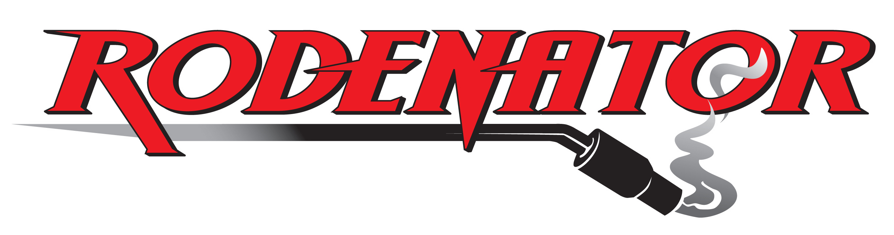

RODENATOR R3 OPERATOR'S MANUAL


Important Notice and Statement to Users
in the United Kingdom

Before assembling and operating this equipment, it is important that this Operator's Manual is read and understood in order to use the Rodenator R3™ in a safe and proper manner.

Under the laws of the United Kingdom, specifically the Wildlife and Countryside Act 1981, the Rodenator R3™ CANNOT be used for the killing or taking of any wild animal.

The specific use for the Rodenator R3™ device in the United Kingdom is to collapse unoccupied or abandoned animal burrow systems only.

Contact the Department for Environment, Food and Rural Affairs (Defra) with any questions you may have on the use of this device in relation to the burrow systems that you propose to collapse!

CONTENTS
Page

Important information about Defra and Natural England I
Letter from Defra II
Defra Position Statement III
Natural England Position Statement IV-V

Notice to the Purchaser VI
Introduction by the Manufacturer, Ed Meyer VII
What you should know about the Rodenator R3 Operator’s Manual VIII
General information and Customer Support IX

Important safety information and Signal Words 1
Safety Symbols 2
Equipment safety guidelines 3
Understanding the operation of the Rodenator R3 device 4
Illustration of the Rodenator R3 - location of main components 5
Preparing to assemble the Rodenator R3 6-7

Assembling the Rodenator R3 and attachments 8
Connecting the Rodenator R3 gas supply hoses to the regulators 9
Connecting the Rodenator R3 regulators to the gas cylinders 10
Connecting the gas supply hoses to the Rodenator R3 10
Testing gas connections for leaks 11-12
Adjusting regulator pressure settings on fuel and oxygen cylinders 13

Setting operational gas mixture for your Rodenator R3 14
Understanding the use of gas mixtures - Liquefied Propane Gas (LPG) 15
Liquefied Propane Gas (LPG) warning statement 15-16
Understanding the use of gas mixtures - compressed Oxygen (O₂) 17

Rodenator R3 - safety precautions 18
Operator safety - Personal Protective Equipment (PPE) 19
Operator safety - working area 20
Operator safety - working equipment 21
Operator safety - positioning, timing and minimum safe distances 22-24

Operation - final checklist 25-26
Operation - firing the Rodenator R3 27
Application guidelines - Questions and Answers 28
Maintenance and storage 29
Changing the batteries 29
Technical support and warranty registration 30
Limited Warranty - what is, and what is not covered 31

Warranty Registration Form 32

Important information about Defra and Natural England

In the United Kingdom, the protection and welfare of wildlife are under the rule of the Department for Environment, Food and Rural Affairs (Defra). This government department is responsible for the conservation of wildlife and landscape.

One of Defra’s roles is to carry out visits to premises to verify that people are complying with the administrative controls contained in certain wildlife legislation. It also works with statutory enforcement authorities to effectively discharge wildlife conservation enforcement and responsibilities.

Natural England is a Defra funded agency committed to conserving and enhancing the natural environment. It is authorized to discharge certain Defra wildlife management functions, including the issuance of licences, investigation of crimes against wildlife and working in conjunction with authorities in enforcement.

Meyer Industries and Rodex Europe Limited recommend that any legal question on the application of the Rodenator R3™, for the collapse and/or removal of targeted animal burrows, is directed at Defra and/or Natural England. Their wildlife officers would be able to provide the operator with the best advice for identifying and determining if a burrow is occupied, as well as the best method to ensure that the targeted burrow is vacant.

For information about Defra and the use of Rodenator products, please refer to our website at http://www.rodenator.co.uk/Defra_2007.doc

For additional information about Defra and their position on Rodenator products:
http://www.defra.gov.uk/wildlife-countryside/vertebrates/legal-pest-control.htm

For information about Natural England:
http://www.naturalengland.org.uk/conservation/wildlife-management-licensing/default.htm

For information about European Protected Species, and
The Conservation (Natural Habitats, etc.) Regulations 1994:
http://www.opsi.gov.uk/si/si1994/Uksi_19942716_en_1.htm

Important: It is recommended, prior to commencing work with the Rodenator R3™, that you check with your local office of one of the authorities listed above, to determine if any protected species exist within the boundaries of your work area. In most cases you are likely to find that any such species will be unrelated to your proposed work and that no concerns are warranted.

However, if you do discover that a particular species may be of a concern, the appropriate agency notifying you will provide advice and options to mitigate these issues. This may be as simple as delaying work until the species has finished nesting, or has migrated to other areas for the season, for example.

I

Letter from Defra
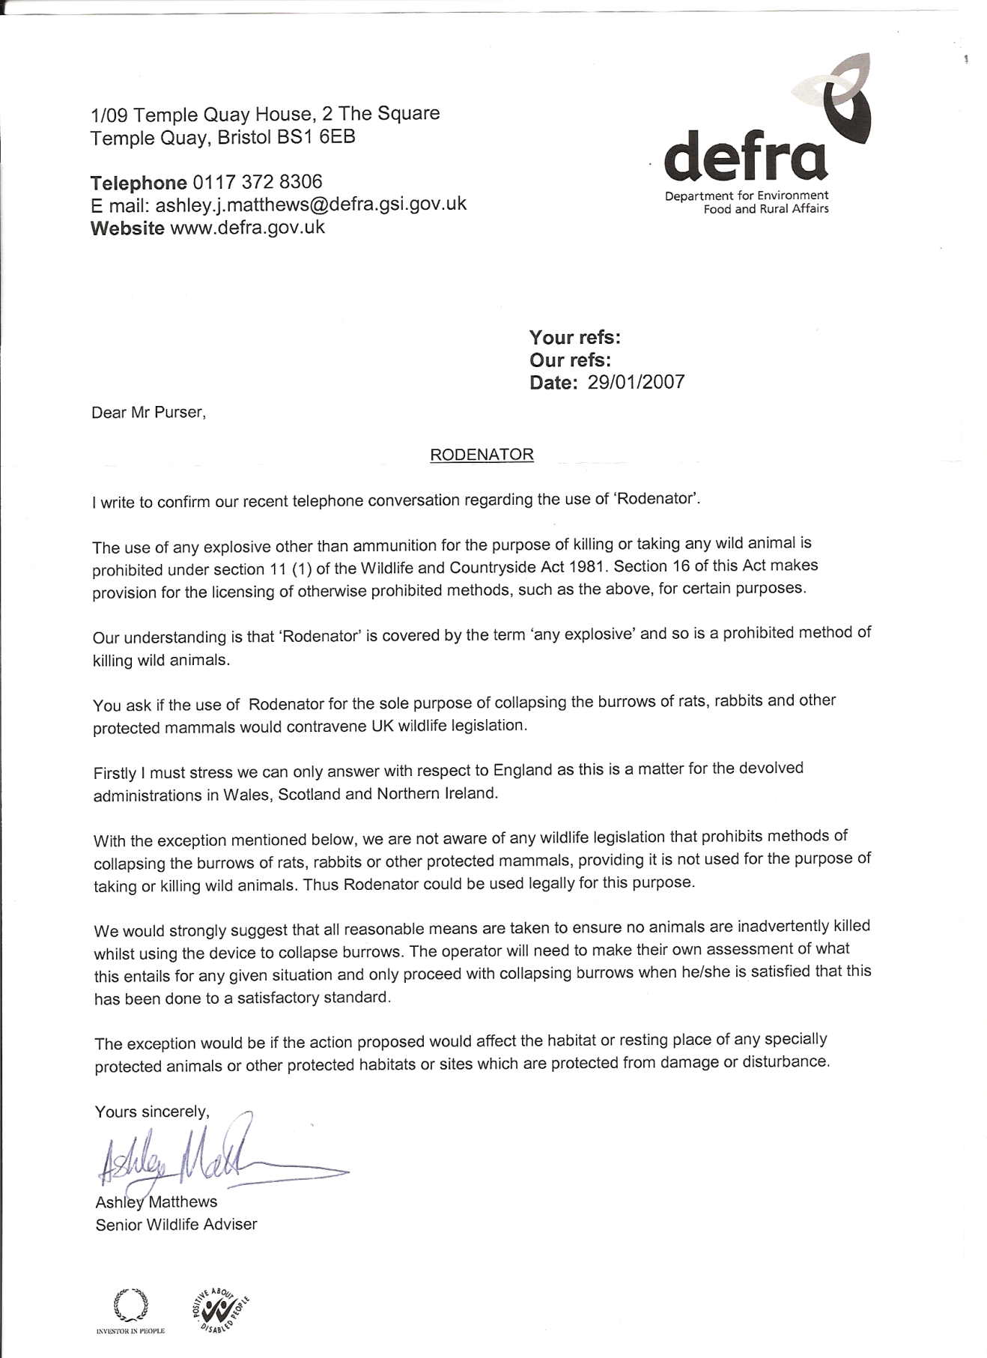

II

Defra Position Statement

DEFRA POSITION STATEMENT
May 2007

RODENATOR and SIMILAR DEVICES

This statement applies to England only as this is a matter for the devolved administrations in Wales, Scotland and Northern Ireland.

The use of any explosive other than ammunition for the purpose of killing or taking any wild animal is prohibited under section 11(1) of the Wildlife and Countryside Act 1981. Section 16 of this Act makes provision for the licensing of otherwise prohibited methods, such as the above, for certain purposes.

Defra’s understanding is that ‘Rodenator’ and similar devices are covered by the term ‘any explosive’ and so are a prohibited method of killing wild animals.

Subject to the exception mentioned below, use of methods to collapse burrows of rats, rabbits or other mammals, is not regulated in wildlife legislation. Therefore, the use of the Rodenator for this purpose would be lawful, provided that it was not used in order to kill or take wild animals.

Defra therefore strongly advises that all reasonable means are taken to ensure no animals are inadvertently killed whilst using the device to collapse burrows. The operator will need to make their own assessment of what this entails for any given situation and only proceed with collapsing burrows when he/she is satisfied that this has been done to a satisfactory standard.

The exception to using Rodenator for collapsing empty burrows would be if the action proposed would affect the habitat or resting place of any specially protected animals or other protected habitats or sites which are protected from damage or disturbance.

Wildlife Species Conservation Team, Defra

Note: As of 1 May 2007 no licenses have been granted to allow the use of Rodenator, or similar devices, for the purpose of taking or killing wild animals in England. Natural England determines such license applications on Defra’s behalf. For Natural England to consider granting such a license, scientific data would be required to allow Natural England to assess the humaneness and effectiveness of the technique.

III

Natural England Position Statement


Natural England
Wildlife Management & Licensing

Natural England calls on Rodenator
users to heed the law

Controlling rabbits, rats and other pests has never been easy but recently a novel pest control device (known as the “Rodenator”) has made its way into the UK market.

Natural England, the Government’s conservation adviser, is warning users that they could be committing an offence if they use devices such as the “Rodenator” in England as a means of killing pests

In recent years the range of control techniques available to manage some of the most problematic species affecting agriculture has narrowed, most notably with the loss of both “Cymag” (used for rabbits and rats) and strychnine (used for moles). Understandably, there has been growing interest in novel techniques to plug the gap.

The Rodenator has received widespread interest. It involves the use of a device that injects an explosive mixture of propane gas and oxygen into a tunnel system which is then electronically ignited. The claim is that the resulting shock wave will kill any animals that are present and collapse the burrows. Devices of this type were first developed in the United States in the 1990s to control a wide range of burrowing mammals and are now being imported into Europe and the UK to deal with rabbits, rats and moles.

Although designed to kill, as the Department for the Environment, Food and Rural Affairs made clear in a public statement in May 2007, Rodenator type devices must not be used for killing wild animals in this country. Legally, they can be used to collapse burrows and tunnels if there are no animals present, and used in this fashion they do not require a licence or Defra approval (no licences have been issued despite claims to the contrary e.g. Farmers Weekly 22 Feb).

Representatives of the pest control industry and animal welfare organisations have expressed concerns to Natural England following reports of apparent illegal use, and a case involving the deaths of wild rabbits was recently documented in the veterinary journal, Veterinary Record. Cases have also been drawn to the attention of the police.

The maximum penalty for using an explosive, other than ammunition for a firearm, to kill wild animals is £5,000 and six months in prison. There is a similar penalty for asphyxiating any wild animal with intent to inflict unnecessary suffering, which is a potential consequence of incomplete destruction of an occupied burrow system.

Natural England has serious concerns about the use of these devices to collapse burrows because of the practical difficulties of ensuring that burrows and tunnels are free of animals. Claims that it takes “one minute per burrow to do the job” and that the device can be used to destroy 250-300 rabbit burrows a day (Farmers Weekly 22 Feb) give rise to concern. Although a thorough and ideally repeated gassing operation using an approved pesticide could eliminate rabbits in a warren system it is unlikely that other techniques including the use of ferrets would do the job sufficiently. The findings of one study confirmed that on average, only 36% of the rabbit population was captured when one ferreting operation was undertaken.

Pest controllers, farmers or anyone else considering using such equipment to collapse empty burrows are advised to carefully consider whether or not they are confident that their proposed use of the device will be legal.
IV

Users should:

- Take all reasonable precautions to minimise the risk that the burrows are occupied by ANY wild animals, making sure that you know which species that use burrows are found in the local area. Placing twigs across entrances can help assess burrow use by larger animals, but don’t forget some species hibernate in other species’ burrows.

- If burrows are occupied, or likely to be occupied, by a problem species, the burrow system will need to be cleared of animals before it can be collapsed. This should be carried out using an effective and legal control method. The most appropriate option will depend on the animal concerned and the situation.

- If the burrow system is occupied, or likely to be occupied, by other animals and especially by protected species, then the burrow should be left undisturbed. Remember that some species, including amphibians and reptiles, may use burrows belonging to other species.

- Make sure that the burrow system is not reoccupied by any animals before the tunnels are collapsed. This will mean preventing access to the tunnels and/or minimising the time interval between clearing the burrows and destroying them.

- If you have reason to believe that there are ANY wild animals in the burrows or are likely to be in the burrows then do not collapse them.

It is also recommended good practice to keep records of measures taken to assess presence of animals and any efforts made to ensure no wild animals were in the burrows when they were collapsed.

These suggestions are offered by way of guidance, and do not in any way lessen the responsibility of users of Rodenator or similar devices to ensure they comply with the law; if in doubt users are advised to seek legal advice.

The question is often “could the Rodenator and similar devices ever be used to kill pest species in England?” The simple answer is yes, but only under an appropriate licence as they utilise a prohibited method of killing. Natural England is authorised to grant such licences on behalf of Defra in England. The Welsh Assembly Government and the Scottish Government are responsible for this issue in their respective countries. To date, there have been discussions between Natural England and importers and purchasers to advise them of the regulatory requirements but no licences permitting the use of these devices to kill wild animals have been granted anywhere in the UK and no such devices are ‘Defra approved’.

Further advice and information
Contact Paul Butt at Natural England. Tel: 01233 811265 email: paul.butt@naturalengland.org.uk

Sources
Defra position statement on Rodenator and similar devices, May 2007: www.defra.gov.uk/wildlife-countryside/vertebrates/pdf/rodenator.pdf

Bidewell C.A., Cantwell, P.J., Scholes, S.F.E. and Duff, J.P. (2008) Deaths of wild rabbits associated with a novel method of pest control. Veterinary Record 162 (5): 163

Cowan D.P. (1984) The use of ferrets (Mustela furo) in the study and management of the European wild rabbit (Oryctolagus cuniculus). Journal of Zoology, London 203, 570-574

Sullins, M. and Sullivan, D. (1992) Observations of a gas exploding device controlling burrowing rodents. Proc. 15th Vertebrate Pest Conf. (ed. J.E.Borrecco & R.E.Marsh) University of California, Davis. 308-311

February 2008
Email: wildlife@naturalengland.org.uk
Website: www.naturalengland.org.uk

V

Notice to Purchaser

E.B. Meyer, Inc. and Meyer Industries, of Midvale, Idaho, USA, give notice to the purchaser and user of the Rodenator R3TM “burrow elimination system” as follows:

The purchaser and user of this product assumes all liability in the operation, application, use, and/or possession of this device, known as the Rodenator R3TM “burrow elimination system”, and releases the manufacturer, E.B. Meyer, Inc. and Meyer Industries, and their agents, distributors, and/or dealers, of any liability and/or damages, in whole or part, including but not limited to the Rodenator device, purchased accessories, gauges, hoses and safety equipment.

The purchaser and user agree to comply with all terms and conditions to the limited warranty, including acceptance that the Rodenator R3TM device is for single user only.

The Rodenator R3TM device cannot be used for rental, co-operative or lease applications. Renting or leasing of this device will void your warranty.

If you are not in agreement with the above terms and conditions of this release of liability, do not use this product.

Instead, immediately notify the seller, Rodex Europe Limited, that you do not accept the terms of this agreement.

Any indication of usage, including the assembly, and/or application of this product, is considered acceptance of the agreement, whereby the purchaser and user stipulate(s) that liability has been accepted and the purchaser and user have released their rights for claims and damages against E B Meyer, Inc. and Meyer Industries, and their agents, distributors, and/or dealers of any liability and damages, in whole or part, including but not limited to the Rodenator R3 device, purchased accessories, gauges, hoses, and safety equipment.

Time Limitation: Upon accepting delivery of this product, which includes this Operator’s Manual, the purchaser and user is required to notify Rodex Europe Limited of their intent not to agree to the terms of this release of liability.

This notification must be postmarked by certified mail within 5 calendar days after delivery.

Expiry of the time limitation without notice indicates that you have accepted the terms and conditions set forth by this release stated above.

VI

Introduction by Manufacturer - Ed Meyer

Thank you for purchasing the Rodenator R3™ “burrow elimination system”. You have the finest device on the market for obtaining complete control of burrowing pests while protecting the environment from toxic chemicals and pesticides.

Manufactured by Meyer Industries, the Rodenator R3™ is designed for farmers and land managers, and is intended for rigorous use by agricultural, commercial and residential users worldwide.

Meyer Industries is always at the forefront of technology. We continually seek advice and recommendations from universities across the USA and frequently commission public studies to demonstrate the effectiveness of the Rodenator products with varied species and applications. We also seek recommendations from our customers who apply our products in varied environments.

In January 2006, the RodenatorTM range of products received US and International approval and verification for use in organic farming applications through Custom Certification Services (CCS).

Our products are now recommended for use by the Organic Crop Improvement Association, International (OCIA), one of the world's oldest, largest and most trusted leaders in the organic certification industry, and many other organic certification and accreditation organizations across the United States, Europe and Japan.

With the exception of traps, our RodenatorTM products are the only devices on the market today that can be used in organic applications.

With our excellent product support and warranty programs, the Rodenator R3™ “burrow elimination system” is a tool that will always give unparalleled results.

When you purchase the Rodenator R3™ or any other product from Meyer Industries, you are becoming not just a customer, but a part of our community.

Edwin B. Meyer, President
E.B. Meyer, Inc.

VII

What you should know about
the Rodenator R3 Operator’s Manual

This Operator’s Manual is intended to provide the purchaser and user with comprehensive information relating to the safety, operation and recommended application techniques for the Rodenator R3™ “burrow elimination system” only.

You are advised to completely read this Operator’s Manual before assembling and operating this device. Failure to read and understand this Operator’s Manual may result in safety issues and performance problems.

This Operator’s Manual and the suggested Rodenator R3™ “burrow elimination system” application techniques are specific to this product and are not applicable to similar products or devices.

All warnings and notices in this Operator’s Manual are intended to give you necessary information for the safe and efficient operation of the Rodenator R3™ “burrow elimination system”.

Please study this Operator’s Manual carefully:

both your safety and the safety of others depend on it!

TRAINING DVD

There is a training DVD supplied with the Rodenator R3 showing how to assemble and use the device. The training DVD should be viewed in conjunction with the Rodenator R3 Operator’s Manual before first using the Rodenator R3. If you lose your training DVD, please contact us for a free replacement, or see it on our website: www.rodenator.co.uk

If you have any questions regarding the assembly, operation or application techniques of the Rodenator R3TM device, cease operation!

Immediately contact:

Rodex Europe Limited Customer Support:

Tel: 07739 799721 or 01480 890348, or

Email your questions to: technical@rodenator.co.uk

VIII

General information

Defra Information:

The Rodenator R3™ is restricted for use in England for collapsing the burrow systems of abandoned or unoccupied animal tunnels, burrows or dens. This device is not to be used for the killing of wildlife without specific licensing or authority by public law.

EPA Information:

The Rodenator R3™ Burrow Elimination System is registered with the United States Environmental Protection Agency (EPA) as an Application Device. The EPA Establishment number is 079470-ID-001.

Patents, Trademarks, and Copyright:

The Rodenator R3™ is registered with the USA Patent and Trademark Office with additional USA and Foreign Patents Pending. All affiliated names, brand and trade names, trademarks, this Operator’s Manual and related materials, documents, videos, brochures, web and/or internet information, newsprint and magazine articles, trade names, tag lines and logos are protected by federal, state and international patent, trademark and copyright laws.

Meyer Industries prohibits the use of its patents, trademarks and copyrights and is protected by law.

Organic Verification:

The Rodenator R3™ Burrow Elimination System is verified for use in organic applications through Custom Certification Services (CCS) of Nebraska. The following countries have verified its use; copies of these verifications are available on request:

- The International Federation of Organic Agriculture Movements (IFOAM)
- The Costa Rica Ministry of Agriculture and Livestock (MAG)
- Japan Agriculture Standards (JAS)
.
Customer support

If you have any questions regarding the assembly, operation or application, have questions not answered in this manual, or if your manual is damaged or misplaced, or you require additional copies for whatever reason, cease operation.

Immediately contact Rodex Europe Limited Customer Support:

Tel: 07739 799721 or 01480 890348, or Email: technical@rodenator.co.uk

IX

Safety information

Safety alert symbols found throughout this manual are used to bring your attention to instructions involving both your personal safety and the safety of others

FAILURE TO FOLLOW THESE INSTRUCTIONS MAY RESULT IN SERIOUS INJURY!


Signal words

Use of the following signal words DANGER, WARNING, and CAUTION with safety messages. The appropriate signal word has been selected using following guidelines:

Indicates an imminently hazardous situation that, if not avoided, will result in death or serious injury.
DANGER

Indicates a potentially hazardous situation that, if not avoided, could result in death or serious injury. It may also be used to alert against
WARNING
unsafe practices.

Indicates a potentially hazardous situation that, if not avoided, may
CAUTION
result in minor or moderate injury. It may also be used to alert against
unsafe practices.

IMPORTANT NOTICE

If you have any questions regarding the safety words or signals, do not operate this
equipment until you have a full and clear understanding of the danger statements, warnings and cautions in this Operator’s Manual.

If you have any questions regarding the assembly, operation, or application techniques of the Rodenator device, cease operation.

Immediately contact Rodex Europe Ltd Customer Support on Tel: 07739 799721 or 01480 890348, or email your questions to technical@rodenator.co.uk

1

Safety Symbols

The following important safety symbols are associated with the operation of the Rodenator R3TM device:

 Indicates that the container or vessel contains a flammable gas that can ignite in the presence of flame, spark, heat or friction.

 Indicates that the container or vessel contains a non-flammable gas that can react to the presence of flame, spark, heat, friction or oil.

 Indicates that protection of head, eyes and hearing is required.
Please use the personal protection equipment (PPE) provided.

Please take note of these safety symbols which are associated with this Operator’s Manual and the Rodenator R3TM device.

2

Equipment safety guidelines

Every year, many farm, ranch and industrial accidents occur that could have been avoided by observing safety precautions and following recommended operating procedures prior to operating or handling equipment.

You, the operator, can avoid accidents by observing all precautions in this Operator’s Manual:

- Do not allow persons to operate or assemble the Rodenator R3 TM device or accessories until they have read the operator’s manual and have developed a thorough understanding of the safety precautions and the proper operation of this equipment.

- To avoid personal injury, study the precautions in this Operator’s Manual and insist that those working with you also follow those precautions.

- Do not attempt to operate the Rodenator R3TM device under the influence of alcohol or drugs.

- Do not cover up, paint over, remove, or deface any safety signs or warning decals on your Rodenator R3 TM device. If any safety, warning or instructional decals are damaged or missing, contact Rodex Europe Ltd Customer Support:

Tel: 07739 799721, 01480 890348 or +441480 890348 for immediate replacement.

- Never exceed the limits of this device. If its ability to do a job, or to do so safely is in question, cease operation immediately and contact Rodex Europe Ltd Customer Support on Tel: 07739 799721 or 01480 890348.

- Your best assurance against accidents is being a careful and responsible operator. Please familiarize yourself with the safety warnings in this Operator’s Manual. If you do not fully understand how to apply the safety protocols in the application of this device, cease operation immediately and contact Rodex Europe Ltd Customer Support on Tel: 07739 799721 or 01480 890348.

Do not attempt to modify or repair the Rodenator R3 TM device in any way. Do not attempt to modify the regulators, hoses, flash arrestors or check valves.

All equipment provided by the manufacturer has been specifically designed for optimal performance and safety. Use exactly what has been provided.

ANY MODIFICATIONS, UNAUTHORIZED REPAIRS, AND/OR FAILURE TO USE COMPONENTS SUPPLIED WITH THE RODENATOR DEVICE WILL VOID YOUR WARRANTY!

3

Understanding the operation
of the Rodenator R3™ device

The Rodenator R3™ Remote “Burrow Elimination System” is an EPA registered application device that injects a calibrated mixture of liquefied propane gas (LPG) and compressed oxygen (O₂) into the tunnels of burrowing animals.

This application is timed from 2 seconds to 3 minutes, depending on the type of unoccupied burrow system that is being treated.

The calibrated mixture dispensed is <2% liquefied propane gas (LPG) and around 98% compressed oxygen (O₂).

During the application, it is recommended that the operator uses a stopwatch or timer for each and every application to ensure that the amount of gas being injected is properly within the recommended application protocols and to ensure safety of the operator and bystanders.

When the recommended time for injection of gases is complete, the operator ignites the mixture by actuating the electronic ignition module button, located on the control box. This initiates a low amperage, high voltage arc caused by a spark plug within the nozzle, causing the gas mixture to detonate within the tunnel system.

The detonation of the propane causes the oxygen to violently react, creating a massive concussive force that travels through the tunnel system which generally disrupts a large portion of most closed tunnel systems, causing them to collapse. This process has been documented repeatedly by extensive field trials and customer response.

Propane and oxygen are the only gas mixtures approved for use
DANGER
with the Rodenator R3TM device.

Any attempt to use acetylene, vaporized gas or Mapp gas, is
dangerous and ineffective with this device.

Due to the explosive nature of propane and oxygen, it is
extremely dangerous to attempt to duplicate this propane and
oxygen process or to experiment with equipment that is not
designed or intended for use with subterranean destruction of
unoccupied or abandoned animal burrows.

Home-made devices have been known to cause serious injuries
and burns.

4
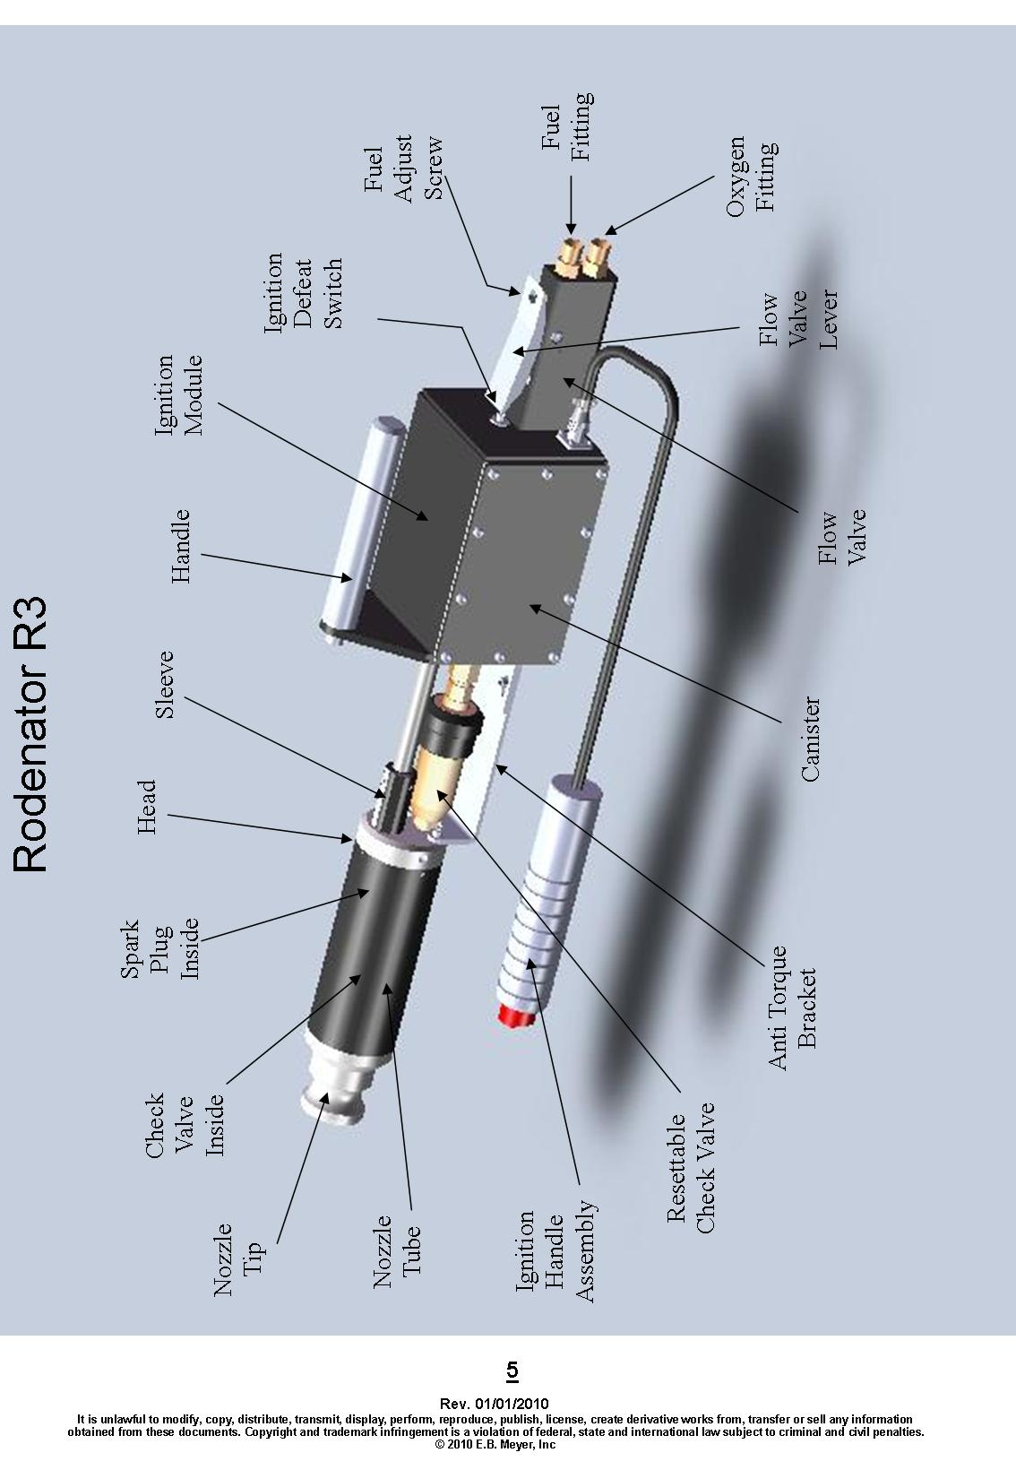
Preparing to assemble
the Rodenator R3™ device

In order to properly assemble the Rodenator R3™ “Burrow Elimination System”, check all items against the following inventory to ensure that all components are in proper order and have not been damaged in transit. Check off each of the components listed:

Component List

Box 1 (“Rodenator box”)

- Rodenator R3™ device

- Flexible extension hose

- Metal extension tube with 45 degree angle

- 8 m ignition cord

- Batteries (fitted)

- Operator’s Manual

- Training dvd

Box 2 (“Accessory box”)

- Propane regulator

- Oxygen Regulator

- 15 m of T-Grade Dual Gas Hose

- Safety Helmet – hard hat, face shield, ear defenders

- Safety Goggles

6

IMPORTANT!

Before assembling your Rodenator R3 unit, please read this manual regarding its attachments, its use and purpose, and its capabilities.

Safety is the BIGGEST concern regarding the use of this product. The main points to remember are:

ALWAYS wear the safety equipment supplied with your R3. The R3 is a powerful tool producing substantial concussive force. It is not a toy! Also remember that it has only 25 feet (8 metres) of ignition cable attached for added safety.

ALWAYS inspect your unit before each day's use for loose fittings, debris in the nozzle, frayed ignition wire or damage of any sort.

ALWAYS secure your Rodenator device in your vehicle when travelling.

ALWAYS use this device only for its intended purpose and design.

NEVER point this device at another human when it could fire - treat it as you would a firearm.

NEVER lower this device into a large hole - instead use the extension hose
provided.

NEVER stand directly over or around the hole you are treating.

The purpose of this device is to destroy the underground habitat by collapsing the tunnel system of the target pest. It is designed first and foremost for use in agriculture where burrowing pests are involved.

If you are an owner or prior owner of any other Rodenator product, the application of the R3 will not greatly differ from the Rodenator Pro™/R1 or the Rodenator Remote™R2.

However the application of the Rodenator R3 is slightly different in that you will not be handling the unit as you ignite the mixed gases. It is controlled remotely by a wire and the method of setting the mix for maximum concussive force has changed.

7

Assembling the Rodenator R3 and attachments

The Rodenator R3 applicator device contains the complete internal electronic controls, ignition mechanism, gas proportioning valves and flashback arrestors within the unit that is assembled at the factory.

The batteries for the Rodenator R3 are located in the handle portion of the 8 metre ignition cord. The Rodenator R3 comes with the first set of batteries installed within the ignition handle. When replacing the batteries use two 9-volt Duracell batteries.

Attaching the 8 metre ignition cord to the Rodenator R3

Attach the female plug on the ignition wire to the corresponding male plug on the rear of the R3. Gently push the female plug in your hand against the mounted male plug and turn until the centre of the plug engages the pins in the male plug. Slide the female plug bezel (ring) against the male plug and turn clock-wise until resistance is felt, usually ¼ to ½ turn. These plugs are very robust but you could bend the inside pins if you force any part of the installation. Be patient!

You will notice a piece of coloured tape on the cord about 2 feet from the female plug. This coloured tape on the cord is to be placed behind and under the gas flow valve when ready to start flowing gas. This will allow you to flow fuel without manually having to stand there holding it. When you have injected the desired amount of gas simply tug on the cord stopping the gas flow and press the igniter button on the igniter handle.

Attaching the flexible extension hose

The rubber flexible extension hose that comes with your Rodenator R3 has cam-locks on either end of it to attach one end of the extension tube to the Rodenator R3. The other end is to be placed in the tunnel system of the targeted pest.

Please keep the flexible hose fairly straight when putting it in the tunnel system. An extreme blast will be travelling through the hose and if there is a sharp bend in the tube you may blow a hole through the flexible extension hose.

Attaching the metal extension tube

Place the metal extension attachment at the end of the Rodenator R3 and attach with cam-locks. This attachment works best if placed directly on the end of the R3 rather than at the end of the flexible extension tube. This attachment is used mainly for rats and moles.

8

Connecting the gas supply hoses to the regulators

CAUTION

- The fuel / oxygen supply hoses are connected between the regulators and the back flow arrestors on the back of the R3 with 11/16-inch female brass fittings.
*Outside of North America, R3 units will be supplied with adaptors to fit your standard thread size. UK users will be supplied with specially developed Good Year hose using 9/16 UNF and 3/8 BSP fittings.

- The connections are compression fittings and do not require the use of pipe dope or threaded tape for connections.

- The blue hose attaches to the oxygen regulator (blue for oxygen). Hand-tighten in a clockwise motion, followed by a wrench for a snug fit.

- The orange hose attaches to the propane regulator using an anti-clockwise motion. Hand-tighten, followed by a wrench for a snug fit.

- Use the fuel hoses that is provided and approved for the use of propane/fuel gases only.

Do not over tighten the gas hose connections. The thread design on the hoses prevents and accidental cross connection hook-up. Oxygen threads clockwise, fuel/propane threads counter clockwise.

The coupling nut on the Propane/Fuel connection is identified with groves stamped into the coupler. This is a reverse or left-handed thread – requiring anti-clockwise turn to tighten.

The coupling nut on the Oxygen connection has no identifying marks on the coupler and is a standard thread – requiring clockwise turn to tighten.

Refer to the Manufacturer’s instructions supplied with each regulator for additional information on connections and tightening procedures.

9

Connecting propane and oxygen regulators to gas cylinders

CAUTION



Liquefied Propane Gas (LPG) is extremely cold in its liquid state. It is recommended that eye protection and gloves be worn when connecting the regulators.

Before connecting regulators, please read the instructions and warnings supplied included with the oxygen and propane regulators and become fully familiar with the operating instructions for the regulators.

- Attach the Dual Fuel (propane) regulator to the propane tank. Use an anti-clockwise motion to hand-tighten the fitting of the propane regulator to the propane tank. Complete the attachment using a wrench to secure the connection. Do not over tighten.

- Attach the oxygen regulator to the oxygen tank (O2), using a clockwise motion to hand-tighten the female fitting of the oxygen regulator to the oxygen tank. Complete the attachment using a wrench to secure the connection. Do not over tighten.

Connecting the gas supply hoses to the Rodenator R3

There are two connections to be made at the back of the Rodenator R3.

- The top fitting on the back of the gas flow handle is the propane/fuel connection, and the bottom connection is for the oxygen.

- The blue hose attaches to the bottom back flow arrestor on the back of the gas flow handle. Hand-tighten in a clockwise motion, followed by a wrench for a snug fit.

- The orange hose attaches to the top back flow arrestor on the back of the gas flow handle. Hand-tighten in a clockwise motion, followed by a wrench for a snug fit.

10

Testing gas connections for leaks

It is necessary to perform a leak test on all connections by using an oxygen safe commercial leak test solution. Failure to test for leaks may lead to a dangerous gas leakage or performance issues.

This must be done in a well ventilated area!

Oxygen Leak Test:

1. Check all connections to confirm that they are tight and secure.

2. Oxygen is stopped at gas flow handle until you depress the handle allowing mixed gas
to flow.

3. Prior to opening the oxygen cylinder valve, loosen the oxygen pressure regulator
adjustment screw (left turn) 1 to 2 turns. This will eliminate overpressure to the
regulator gauges when the cylinder valve is opened.

4. Carefully open the cylinder valve on the oxygen cylinder only.

5. Use leak testing solution on all connections, beginning at the regulator connection to the cylinder, and continuing with all hose connections, right up to the gas valve on the Rodenator R3.

6. If a leak is detected, close the oxygen cylinder valve, wait for the pressure to bleed off, tighten the leaking connection, and then re-test.

Propane Leak Test:

A. Check all connections to confirm that they are tight and secure.

B. Close propane control adjustment set screw on top side of gas flow handle. This can
be seen through a hole in the rear of the gas flow handle. Turn clockwise to close.

C. Carefully open the cylinder valve on the propane cylinder only.

D. Use leak testing solution on all connections, beginning at the regulator connection to
the cylinder, continuing to all hose and gas line connections.

E. If a leak is detected, close the propane cylinder valve, wait for the pressure to bleed off, tighten the leaking connection, and then re-test.

F. When connections are tight and no leaks are detected, close the propane cylinder valve and continue with the assembly procedure in this Operator’s Manual.

11

Testing Connections for Leaks – continued

DANGER

Do not use any petroleum products on or near the equipment, regulators and hoses, including oils, solvents and cleaners.

Do not use any cleaners or solvents that are not “oxygen safe”.

Make sure that hands and tools are free of oil and grease.

Oxygen vigorously accelerates combustion and may form explosive compounds when exposed to combustible materials or oil, grease, and other hydrocarbon materials.

Improperly cleaned equipment and piping could result in a combustion reaction causing damage to equipment and injury to personnel.

When performing leak tests, using an “oxygen safe” testing solution is essential to preventing contamination of your oxygen source.

If you are unsure of the product you are using for leak testing, consult a welding or oxygen supply dealer for recommended products that are “oxygen safe” and free of oils and hydrocarbons.

12

Adjusting regulator pressure settings
on propane (fuel) and oxygen gas cylinders

Compressed Oxygen – O2:

1. Prior to opening the oxygen tank valve, loosen the oxygen pressure regulator
adjustment screw (left turn) 1 or 2 turns. This will eliminate overpressure to the
regulator gauges when the tank valve is opened.

2. Open up the oxygen cylinder to the fully open position.

3. When in flow, adjust and set the oxygen regulator to a 3 bar (44 psi) gauge reading,
by turning the pressure adjustment knob on the regulator in a clockwise motion.

4. After your initial adjustment to the regulator settings, occasionally check the pressure
settings while the gas is flowing to ensure that the pressure is correct. The flow
pressure will increase as the pressure in the cylinder reduces. Please correct the
pressures as necessary.

Liquefied Propane Gas – LPG/propane:

1. Open the propane cylinder to the fully open position.

2. When in flow, adjust and set the propane regulator to a 3.2 bar (47 psi) gauge reading, by turning the pressure adjustment knob of the regulator in a clockwise motion.

3. After your initial adjustment to the regulator settings, occasionally check the pressure
settings while the gas is flowing to ensure that the pressure is correct.

It is recommended to check both regulator pressures while the gas is flowing through the hoses. This will ensure that the pressures are correct during the application.

13

Setting the operational gas mixture for the Rodenator R3

It is recommended that the following is done outdoors and that ear defenders are worn throughout the procedure.

1. Set propane/fuel regulator to 3.2 bar (47 psi) while the gas is flowing through the end of the R3 unit. (See Note below with reference to setting new R3 units).

2. Set oxygen regulator to 3 bar (44 psi) while the gas is flowing through the end of the R3 unit.

3. Adjust the fuel metering screw on the top of the gas flow valve to 1/8 turn open.

4. Depress the gas flow valve. Identify a 3/8" hole through the flow lever to the rear of the unit, near the fuel port. Open the fuel metering screw 1/8 turn open. Let the gas flow for 3 seconds and depress igniter button located on the igniter handle at the end of the 8 metre ignition cord.

5. If gas does not ignite, open the propane/fuel control adjustment screw to 1/4 turn
open and repeat step (4).

The propane/fuel adjustment screw is located below the gas release handle, accessed via a 3/8 inch hole in its rear. With both regulators set at the correct pressures, the propane/ fuel adjustment screw is to be opened just enough to enable the gas mixture to ignite.

Using a flat screw driver, make sure the screw is seated at the bottom by turning clock-wise. Please do not use excessive force! Next, turn the screw anti-clockwise 1/8 a turn open to start. If gas does not ignite, adjust set screw to ¼ turn open up to ½ turn open, just open enough to get the gas to ignite. This will help regulate the fuel flow.

14

Understanding the use of gas mixtures

Understanding the combined effect of propane and oxygen in the use of the Rodenator R3 is important. The Rodenator R3 uses a proprietary method to proportion, compress and inject the gas mixture into the tunnels of burrowing pest animals. The mixture contains around 2% liquefied propane gas (LPG) with the balance as compressed oxygen (O2).

This mixture produces a compressed ratio of propane and oxygen at a consistent measured pressure into the tunnel system. Upon combustion, the resulting concussive force of 10,000 psi travels throughout the tunnel system as a shockwave at over 5,000 m/second.

This concussive force is sufficient to collapse animal burrows, and additionally to humanely exterminate the targeted pest in situ when carried out elsewhere in the world.

Please note that the Rodenator R3 is sold in the UK for the destruction of empty, uninhabited, pest species tunnel systems only!

The combustion of LPG and oxygen produces carbon dioxide (CO2) and water vapour and is therefore non-toxic to the environment.

Liquefied Propane Gas (LPG) - Warning Statement

- Propane is a highly flammable gas. It is heavier than air, which gives the mixture added weight for better tunnel penetration and to assist the oxygen in the process of rapid expansion.
- Always maintain proper regulator settings as excessive propane creates a potential fire hazard and slows down the shock wave resulting in a fire.

DANGER

FIRE HAZARD

Liquefied Propane Gas (LPG) is highly flammable gas vapour that produces an explosive mixture with air and will easily ignite by heat, sparks, flames, build-up of static electricity, and other sources of ignition. Do not smoke or use electrically operated devices while connecting and/or operating this device. Propane vapour is denser than air and may flow along the ground, sinking to the lowest level of the surroundings, and it can be ignited at a considerable distance from the source of leakage.
15

LPG Warning Statement - continued
Propane contains an odorizer to alert users of leakage. Test all connections with an oxygen safe leak detection liquid to assure tight fittings and connections. If you detect a leak, immediately close all tank valves. Do not check for leaks with an open flame!
If a leak is detected from the propane tank and you are unable to secure the leak, immediately evacuate the area and contact the Fire Brigade.
Refer to the relevant Safety Data Sheets for these materials before using, to familiarize yourself with the precautions for handling, storage, firefighting and proper use of these materials.

WARNING

INHALATION HAZARD

At very high concentrations in an enclosed area, liquefied propane gas (LPG) vapor is an asphyxiant which will decrease the availability of oxygen. This product will displace oxygen if released in a confined space. Maintain oxygen levels above 19.5% at sea level to prevent asphyxiation. Inhalation of high concentrations may cause dizziness, disorientation, loss of coordination or loss of balance, narcosis, nausea or narcotic effects.

CAUTION

EXTREME COLD HAZARD - EYE AND HAND PROTECTION

Liquefied Propane Gas (LPG) in its liquid state can cause cryogenic burns to the skin similar to frostbite.

Protective clothing, including hand and eye protection is recommended when affixing connections and testing for leaks.

Refer to the relevant Safety Data Sheet for these materials before using, to familiarize yourself with the precautions for handling, storage, firefighting and proper use of these materials.

16

Understanding the use of gas mixtures: compressed Oxygen (O₂)

Compressed Oxygen (O₂)

- Oxygen is an oxidizer that rapidly accelerates with an ignition source (propane).
This rapid expansion creates a shockwave effect at a rate of over 10,000 psi within the tunnel system.

- Always maintain proper regulator and valve settings, as excessive compressed oxygen will cause improper detonation of the propane, which may create a potential fire hazard.

DANGER

FIRE HAZARD
Compressed Oxygen is a non-flammable gas that vigorously accelerates the combustion process of the propane within the tunnel or burrow.
Do not smoke or use electrically operated devices while connecting and/or operating this device.
Test all connections with an oxygen safe leak detection liquid to assure tight fittings and connections. If you detect a leak, immediately close all tank valves. Do not check for leaks with an open flame!
If a leak is detected from the oxygen tank and you are unable to secure the leak, immediately evacuate the area and contact the Fire Brigade.
Do not use oil on any fittings. Keep safety caps on oxygen cylinders at all times.
Refer to the Material Safety Data Sheet on these materials before using to familiarize yourself with the precautions for handling, storage, firefighting and proper use of these materials.

17

Safety precautions
when using the Rodenator R3TM

Learn how to handle your Rodenator R3TM safely. Failure to read, understand and follow these recommendations can result in serious personal injury and/or property damage.

WARNING

The Rodenator R3™ Burrow Elimination System is designed and intended for use as a device for collapsing unoccupied or abandoned burrowing pest systems only.

Using this device outside of the scope of what it is intended for, and not in accordance with this Operator’s Manual and public law, is strictly prohibited.

Any intentional misuse of this device may compromise the safety of the user or bystanders and may void the warranty.

Any intentional misuse of the Rodenator device outside of the scope of collapsing unoccupied or abandoned burrowing animal tunnel systems can be deemed to be a violation of public law in the United Kingdom.

The user of this device understands and agrees that no warranties or guarantees have been made on the performance of the Rodenator R3™ Burrow Elimination System.

Total responsibility for the safe operation of this device lies solely upon the user and not with the manufacturer, Meyer Industries, and/or their representatives.

REMEMBER, the best assurance against accidents is being a careful and responsible operator. Please familiarize yourself with the safety warnings in this Operator’s Manual.

If you have any questions regarding the assembly, operation or application techniques of the Rodenator device, cease operation. Immediately contact Rodex Europe Limited Customer Support on Tel: 07739 799721 or 01480 890348.

Alternatively, email your questions to technical@rodenator.co.uk

18

Operator safety

Personal Protective Equipment (PPE)

It is recommended and advised that Rodenator R3TM operators wear the following items:

Clothing

- Wear long sleeved shirt and trousers.

- Wear gloves to protect hands.

- Never wear shorts, t-shirts or any highly flammable clothing.

Shoes

- Wear footwear that completely encases the foot and ankle.

- Wearing work boots is recommended. Trainers are not acceptable.

- Never work without recommended footwear.

Head, face and hearing protection

- Wear safety glasses and hearing protection.

- Provide additional hearing and eye protection to workers or observers standing nearby.

19

Operator safety - working area

CAUTION

KEEP THE APPLICATION SITE CLEAR OF BYSTANDERS

- Flying dirt or mud may cause injuries.
- Loud noise may cause hearing loss or frighten people, pets or livestock.
- Keep bystanders (especially children) and pets at least 30 metres from the work area.
- Provide eye and hearing protection as required.

Flammable Materials

- Do not use in or near dry grass and brush.
- Exercise caution when working near fuel containment areas, propane tanks, underground fuel tanks and buildings.
- Carry an approved fire extinguisher for suppression of grass or brush fires.

DANGER

FIRE HAZARD

- Do not make any applications within 60 metres of any surface or underground flammable storage containers or tanks.
- Maintain a distance of 60 metres from any other flammable storage areas.
- Do not use within 30 metres of a septic tank or drain system.
- Propane and oxygen are the only gases to be used in the R3™ device.
- NEVER use acetylene, Mapp gas or vaporized gasoline.

Noise

- The discharge noise from the R3™ device may be loud.
- Wear hearing protection at all times.
- Ensure that bystanders within 30 metres of the application area wear hearing protection.
- Notify neighbors before operating the R3™ device.
- Consider contacting local law enforcement prior to use to avoid false calls.

20

Operator safety - working equipment

Check your equipment frequently

- Test hose connections and all threaded connections/connectors with an “oxygen safe” leak tester to assure that all connections are tight.
- Check gauges and hoses regularly to assure proper settings and tank volumes.

Treat the equipment with care

- Treat the Rodenator R3TM device as you would handle and secure a firearm.
- Do not throw the Rodenator R3TM device into the bed of a truck or vehicle.
- Keep the unit racked and secured while travelling.
- Close both tank valves and bleed system prior to transporting to and from work area.
- Store equipment is a secure area and away from children.

Secure all gas cylinders to vehicle bed

- Take every precaution to prevent cylinders from bouncing, over-turning, and damaging the gauges.
- Use government approved valve protection caps while regulators are not connected to valves.
- Use government approved safety caps when regulators are connected to valve.
- Use government approved devices to secure cylinders to vehicle, trailer or ATV.
- When in use, store cylinders in upright position, secured to tank cart or chained to wall.
- Check with your propane and oxygen supplier on local and state laws regarding the transporting and securing of the gas cylinders.

Notice: For additional information on the transportation of pressurized gas cylinders by vehicle on public roads, consult the following:

- Local propane and oxygen supplier

- UK Department of Transport

- The Health and Safety Executive (HSE)

21

Operator safety - Rodenator R3 positioning
1/
Take great care not to place the Rodenator within the blast zone! Exposing the machine to the full concussive force by inserting it into the burrow can result in trauma damage to sensitive internal components. Instead, use the flexible nozzle extension pipe provided to keep the machine well clear of the blast zone, as shown below:
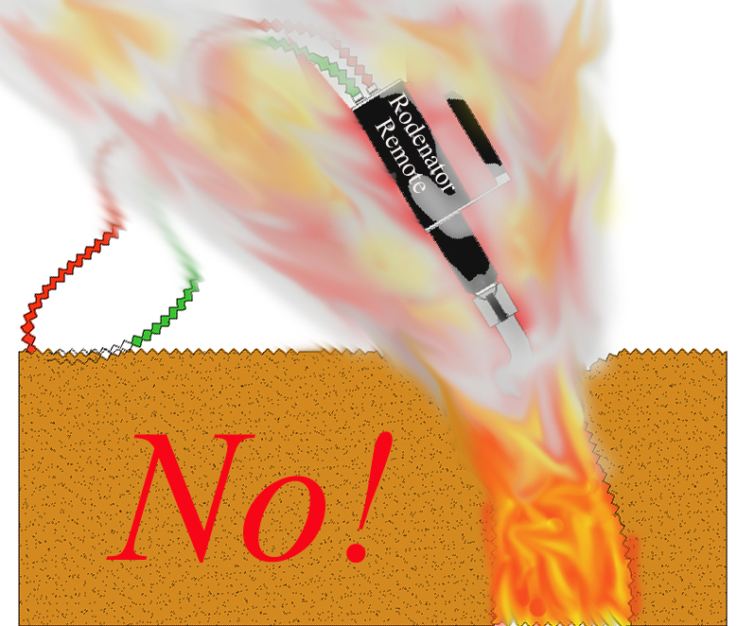
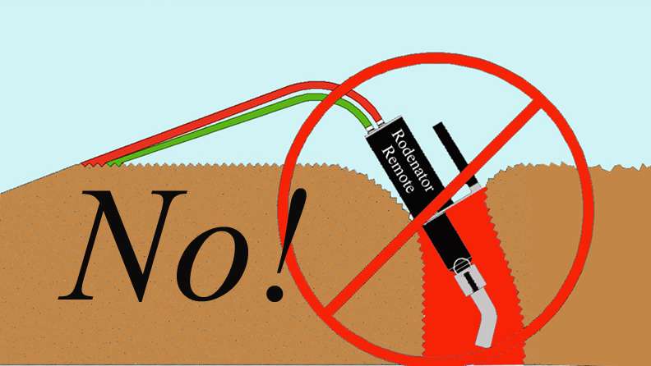
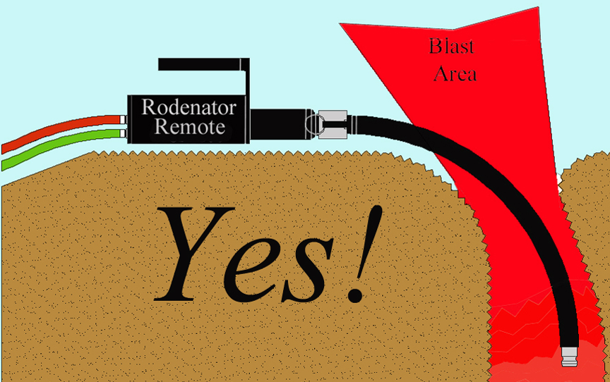

22

Operator safety - operator positioning

- Stand clear of the application area and do not stand directly in front of the hole.
WARNING

Stand on firm soil only

- Due to the shockwave generated at the time of ignition, the operator must exercise caution to limit exposure of himself to the concussive forces exiting open holes.
- Position yourself at least 6 metres from the application area to avoid shockwave.
- Face away from blast.
- Look around for other materials that may become airborne and could cause injury.

Operator safety - timing of gas applications

Timing the application

- To prevent over-gassing a tunnel or burrow system, it is recommended that the operator times the gas application with a watch that can count seconds.
- Timing of the application will vary with the type of animal burrow, soil composition and soil moisture.

Recommended gas application times

We advise gassing times of:

20 seconds to 1 minute for mole tunnels

30 seconds to 1.5 minutes for rat holes

30 seconds to 3 minutes for rabbit burrows; 3 minutes advisable for larger burrow systems

Note: Over-application of gas into a tunnel or burrow system wastes propane and oxygen.

If in any doubt on appropriate gassing times, please call Rodex Europe Limited Customer Support on 07739 799721 or 01480 890348

Do not restrict the tunnel system opening

- Objects placed over open holes may create the potential hazard of flying debris.
- If using a towel or rag over open burrows on windy days, dampen the material to prevent it from possibly smouldering.
- Use of soil is acceptable, but beware of the projectile risk of stones and flints etc.
- Do not place the Rodenator R3TM within the blast zone! (see p.20)

23

Operator safety - operator positioning - continued

Minimum safe distances

DANGER

Keep a minimum distance of 60 metres away from any above ground propane or fuel storage tanks, or further if it is known or suspected that connecting burrows run towards them.

Keep a minimum distance of 60 metres from any underground propane or fuel storage tanks, or further if it is known or suspected that connecting burrows run towards them.

WARNING

Exercise extreme caution when operating the Rodenator R3TM near people, vehicles, buildings and domestic animals. Beware the risk of damage or injury from flying debris, particularly to glass windows of parked work vehicles.

Bystanders should remain a minimum of 30 metres away from the application work area due to the risks of both noise and flying debris.

The minimum safe operating distance from any building should be 15 metres, or further if it is known or suspected that connecting burrows run towards them.

If working near buildings or structures determine the location of septic systems, and exercise a minimum safe operating distance of 30 metres from the holding tank and connecting pipelines.

24

Operation: final checklist

Ensure proper operation, maximum safety and good results

- Wear protective clothing and safety gear.

- Inspect the Rodenator R3TM device unit daily on work days.

- Check all hoses and connections for leaks. Use “oxygen safe” leak tester.

- Check fire prevention equipment. Have fire extinguisher or shovel at hand.

- Set gauges and valves. Monitor gas usage to avoid running out of gas unexpectedly.

- Clear the area of bystanders.

- Proceed with the application.

- Ensure Rodenator R3TM Remote is placed well clear of the blast zone (see p.20).

- Announce the firing of the device.

- Make doubly sure that you are performing the application to unoccupied or abandoned animal burrows.

- Contact your local Defra or Natural England wildlife official if you have any questions relating to the application of this device.

If you have any questions regarding the assembly, operation or correct application of the Rodenator R3TM Remote device, cease operation.

Immediately contact Rodex Europe Limited Customer Support:

Tel: 07739 799721 or 01480 890348, or

Email your questions to technical@rodenator.co.uk

25

Preparation

Inspect equipment before each day’s use

Check for damage to:

- Gas cylinders and valves;
- Regulators and gauges;
- Valves and knobs;
- Hoses and hose fittings;
- Applicator shaft and nozzle, igniter button, applicator head, and canister damage.

Keep equipment clean

- Clean away dust and mud from the unit using damp cloth followed by dry cloth where necessary.

Test the igniter regularly

- The igniter should be tested ONLY in the ABSENCE of gas in the applicator nozzle, i.e. the igniter should be tested ONLY when no gas is flowing, and ONLY when there is no residual gas left in the system.

- The igniter signal, identifiable as a rapid click, should be strong and audible. Replace batteries when necessary using Duracell 9 volt batteries only.

Inspect applicator head frequently

- Check for dirt or mud inside the nozzle head. Remove any dirt or mud build-up with a dry cloth.

CAUTION

HIGH VOLTAGE!

Never place fingers inside the applicator head (nozzle) while the igniter button is being pressed.

26

Firing the Rodenator R3 device

1. Place the R3 in a pest tunnel system

Place the R3 flat on the ground with the rubber extension tube attached to the end of it pointing down the tunnel system of the pest animal you are working with. It is important to pack dirt/mud/damp packing around the rubber extension hose; this will dampen the noise coming out of the tunnel system and force the blast down the tunnel. Do not place R3 device inside the tunnel system, the rubber extension hose is designed to keep the R3 out of the blast zone.

2. If necessary, cock (reset) the flash arrestor

Prior to each application, the big brass flash arrestor should be in the open position exposing the green O-Ring. If it is not already in this position, pull the black ring on the check valve toward the canister until you hear or feel a “click”. You will see the green ring is exposed from under the black collar when pulled up. This flash arrestor is a safety device that may activate from time to time. This is not a fault; you will know if it has been activated when you depress the flow lever and no gas exits the R3; the green O-ring is not visible and the valve needs to be opened and re-cocked.

3. Depress the gas release lever

Press down on the gas lever on the back of the R3 to begin the gas flowing into the tunnel system. Place detonation cord under the back of the flow lever to allow the gas to flow without the operator holding down the gas flow lever. There will be a piece of coloured shrink tube approximately 2 feet behind the plug-in on the detonation cord; this coloured shrink tube is the part of the cord to be placed under the flow lever.

4. Detonate the gas mixture

When the desired amount of fuel is injected into the tunnel system it is time to ignite the gasses. Gently tug on the detonation cord releasing it from holding the gas flow lever flowing. With the gas no longer flowing, you will next press the button on the top of the ignition handle. If you try to ignite the gas before the cord is removed from the back of the gas flow handle, nothing will happen. There is a toggle switch on the back of the canister that is depressed while the fuel is flowing, this toggle switch is a “kill switch” while the fuel is flowing preventing you from accidentally igniting the gas while flow is on.

CAUTION

If any flame emerges from the hole, the fuel setting on the gas flow handle is set too high. Adjust the fuel set screw down by 1/16 increments, until yellow flame is gone, and only a white/blue flash is visible when gas mix is ignited. This will prevent an unexpected fire from starting in most cases.

27

Application guidelines
Introduction

The Rodenator R3™ Burrow Elimination System is designed for the elimination of unoccupied or abandoned subterranean animal burrows, dens and tunnels.

As previously clearly stated in this Operator’s Manual, safety is paramount when operating the Rodenator R3TM. Please familiarize yourself with the safety warnings herein.

If you are not clear or do not fully understand how to apply the safety protocols in the application of this device, cease operation and call Rodex Europe Limited Customer Support for advice.

Questions and Answers

The following questions are often asked and may provide insight into certain situations that fellow Rodenator R3™ Burrow Elimination System owners have experienced.

Q. What about damage to nearby underground irrigation and water pipelines?

A. There have been no reported cases of damage to buried concrete pipes, or PVC piping
used in irrigation or water supply, in the vicinity of Rodenator R3TM use. There have been no reports of damage to buried drip irrigation lines or drainage pipes.

IMPORTANT: Never use the Rodenator R3TM in pipelines themselves, because serious damage will inevitably occur.

Q. Is there potential for setting fire to dry grass?

A. The Rodenator R3™ Remote Burrow Elimination System should not be used under
very dry conditions and during periods of high fire danger, in or near areas of dry
grass, brush or crops.

Fire prevention equipment (such as fire extinguishers, water hoses, fire blankets,
shovels and rakes, etc) should be readily available at all times. Contact your local Fire
Brigade to check for any further restrictions prior to use.

Q. How loud is the report following ignition?

A. The size of the burrow entrance determines the loudness of the blast. Rats and moles,
for example, dig very small openings and tunnels, and therefore the sound of the
discharge may not be very loud. By contrast, the large burrows dug by rabbits can
create a very loud sound.

IMPORTANT: Always use hearing protection when using the Rodenator R3TM.

28

Maintenance and storage

The Rodenator R3 should be inspected before each day’s use and cleaned after use to ensure proper performance. Because much of the Rodenator R3 is encased within the canister, there are few exposed parts subject to environmental damage.

Wipe down the system

The complete system should be cleaned using a damp cloth, and followed with a dry cloth to remove excessive moisture.

Storage of the Rodenator R3

When you are finished using your Rodenator R3 for the day you should equalize the pressure in the gas lines by first shutting both propane and oxygen cylinders. Next depress the gas flow handle on the R3 until you stop hearing any gas flowing through it.

When storing the Rodenator R3 device it is important to cover any openings on the gas lines with a cap or tape. For example, you have taken the regulators off of the cylinders of gas and unhooked the hoses on the R3 device. Cover both ends of the fuel/oxy hose where gas flows, as this will keep insects and dirt out of the gas line preventing a contamination in the gas lines when next in use.

Retain all plastic dust covers and replace the covers over the gas fittings to ensure against dust and moisture contamination of the system.
Please retain the original shipping box in case you ever need to return the Rodenator for repairs.

Changing the Rodenator R3 batteries

Your Rodenator R3 unit has come with 2 Duracell 9-volt batteries already installed in it ready for use. When it is time to replace the batteries they are located in the ignition handle at the end of the 8 meter ignition cord inside the handle with the igniter button on it.

To replace the batteries, unscrew the bottom of the handle and gently pull the wires and batteries out of the handle. Replace the 2 x 9-volt Duracell batteries and replace the screw cap.

29

Technical support and warranty registration

Technical support

Meyer Industries and Rodex Europe Limited offer free Technical Support to all registered customers that are the original purchasers of the Rodenator R3 device.

UK: Rodex Europe Limited

Our Technical Support telephone numbers are 01480 890348 and 07739 799721

Warranty registration

To receive warranty service and technical support for your Rodenator R3 device, Rodex Europe Limited requires that the purchaser completes the attached warranty form and returns it to us within 30 days of purchase.

By signing this warranty form, the purchaser acknowledges that they and/or their proposed operators, have fully read and understand the information in this Operator’s Manual, including the application guidelines, safety protocols, liability agreement and warning information.

Please record your Rodenator R3 Serial Number here:
R3-

Date of purchase: ________________________

Rodenator limited warranty

Meyer Industries and Rodex Europe Limited warrant the original Purchaser that the enclosed Rodenator R3 is free from defects in material and workmanship under normal use and service for a period commencing on the date of purchase and continuing for a period of 1 year from the date of original purchase, except in the case of the Rodenator R3 applicator head and the R3’s internal electronic components, which carry a no-quibble lifetime warranty.

Product Registration is required to activate this warranty!

This Warranty applies to the original registered purchaser and in non-transferable!

30

Limited warranty

What is covered:

During the applicable warranty period, Meyer Industries and Rodex Europe Limited will repair or replace at their option, without charge to the Purchaser, any defective component part of the Rodenator R3 device. However, with regard to the accessory products (hoses, regulators, safety equipment), please note that these are warranted by their respective manufacturers. Warranty information on the accessories is included in the original packing supplied with the Rodenator system.

To obtain service under this limited warranty, the purchaser must contact Rodex Europe Limited in the first instance on Tel: 01480 890348 with a detailed description of the problem with the product. Many Rodenator performance issues can be sorted over the phone and appropriate spare parts sent out.

In some instances, Rodex Europe Ltd will need the machine to be returned to their workshops. This will be done at the Purchaser’s expense. The onus is on the Purchaser to ensure that the machine is suitably packaged, ideally in the original box, and that it is adequately secured and properly insured in transit. Return to:

Rodex Europe Ltd, West Farm, The Lane, Easton, Huntingdon, Cambs PE28 0TY

What is NOT covered:

The limited warranty is conditional upon proper operation and use by the Purchaser. This limited warranty does not cover:

- Defects or damage resulting from accident, misuse, abuse, neglect, unusual physical stress, or modifications of any part of the product.

- Equipment that has had the serial number removed or made illegible.

- Malfunctions resulting from the use of the Rodenator R3 in conjunction with ancillary or peripheral equipment not furnished by or approved by Rodex Europe Limited.

- The use of gases not designed for the Rodenator R3.

- Defects or damage from improper operation, maintenance, installation, adjustment or unauthorized service or repair.

- Any accessory that is included with the Rodenator R3 that is normally covered under a manufacturer’s warranty for said accessory, including but not limited to; regulators, hoses, safety equipment and any other part or accessory that has not been produced and warranted by Meyer Industries or Rodex Europe Limited.

31

WARRANTY REGISTRATION FORM

Important: To receive service and support from Rodex Europe Limited, please fill in and return this form within 30 days of purchase!

By signing this warranty, the customer acknowledges that they have read and fully understand all of the instructions in the Rodenator R3 Operator’s Manual.

Please post this form directly to Rodex Europe Limited. Thank you!

Rodex Europe Ltd
West Farm
The Lane
Easton
Huntingdon
Cambridgeshire Tel 01480 890348
PE28 0TY Mob 07739 799721

Date of Purchase: Rodenator R3™ Serial Number: ____________

Name/Company/Organization: _______________________________________

Contact Name: _____________________________Role: __________________

Signed: __________________________________ Date: __________________

Full Address: _____________________________________________________

_________________________________________________________________

_________________________________________________________________

Postcode: ________________________________________________________

Daytime phone: _____________________ Mobile: _______________________

Alternative phone: _________________________________________________

Email: ___________________________________________________________

Email 2: __________________________________________________________

Fax: ______________________________

32

